Nita M. Lowey 21st Century Community
Learning Centers Grant Program
2022 – 2023 FACT SHEET

PROGRAM OVERVIEW

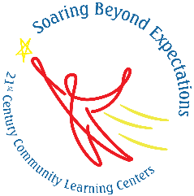
The 21st Century Community Learning Centers (21st CCLC) grant program supports the creation of local out-of-school time (OST) programs to provide students and their families with high-quality academic enrichment opportunities and services. Centers serve students—particularly those who attend high-poverty and low-performing schools—and provide academic and enrichment services during non-school hours. Services focus on helping children succeed academically by:

Providing opportunities for academic enrichment, including tutoring services and homework help, to help students meet state and local academic standards;

Offering students a broad array of additional services, programs, and activities that are designed to reinforce and complement the regular academic program of participating students; and
- Offering families of students served by community learning centers opportunities for active and meaningful engagement in their children’s education, including opportunities for literacy and related educational development.

FUNDING COLORADO’S 21st CENTURY COMMUNITY LEARNING CENTERS
Colorado’s Nita M. Lowey 21st Century Community Learning Centers (21st CCLC) program is administered by the Colorado Department of Education (CDE) and provides subgrantees with multi-year grant funding to establish or expand out-of-school time (OST) programming to K-12 students, with priority given to students attending low-performing and high-poverty schools, as well as families of those students. CDE distributes most of the U.S. Department of Education’s annual allocation to subgrantees, on average retaining seven percent of the total state allocation to cover indirect and administrative expenses.

In addition to these federal program funds, CDE also dedicated state Elementary and Secondary School Emergency Relief (ESSER) funds to support community learning centers in Colorado in 2022. Over $4.3 million ESSER II and ESSER III funds were awarded to 12 E2 OST subgrantees each year for three years who applied for 21st CCLC funds through the Cohort 9 21st CCLC RFA process in FY 2022-2023.

21st CCLC SUBGRANTS
In 2022-2023 CDE managed three cohorts of subgrantees (Cohorts 8, 9, and E2 OST) for a total of 69 subgrants and 134 centers across Colorado. Subgrants were evenly distributed between community-based organizations (CBOs) and local educational agencies (LEAs) with some consortiums. Centers are funded between $64,000 and $150,000 annually.
While E2 OST subgrants are limited to a three-year grant period due to ESSER funding timelines, all 21st CCLC funded sites in Colorado operate on a three-year grant cycle with the option to continue funding for up to two additional years of funding if they meet exemplar criteria. Cohort 8 was in the last year of their two-year continuation period in 2022-2023. In general, CDE releases new grant competitions every two to three years, which is intended to align with the end of a cohort grant cycle. CDE launched the Cohort 10 subgrant competition in March of 2023 and Cohort 8 fiscal agents were eligible to apply for these funds.

The map below shows the geographic distribution of funded centers across all regions of the state. The area pulled out in the upper right corner shows the distribution of programming in the Denver metro area.

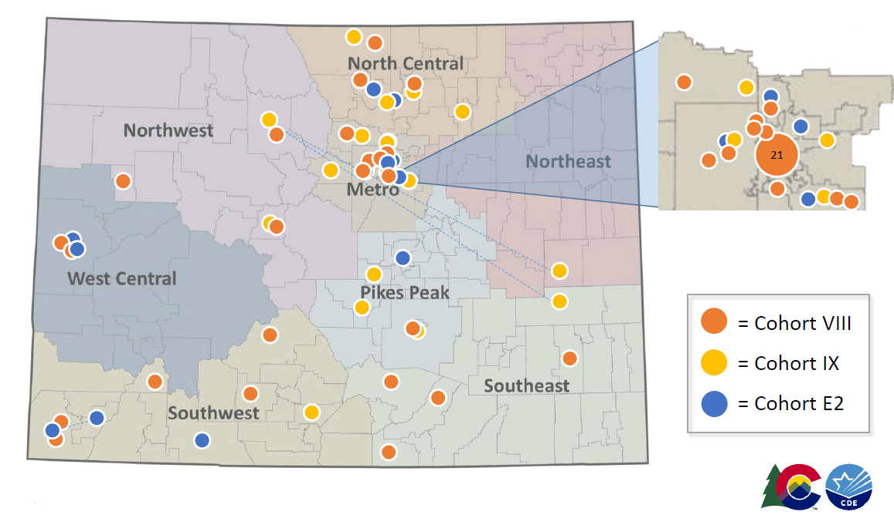

= Cohort 8
= Cohort 9
= E2 OST

21st CCLC ATTENDANCE IN 2022-2023
CDE requires all subgrantees to propose participation targets for each center and monitors their progress in meeting approved participation targets throughout the grant period. The table below summarizes 2022-2023 data for three of the four participation targets required by CDE (Average Daily Attendance outcomes are not included below).

*If PK students were served in programs, they were served as part of subgrantees' family engagement activities.

COMMUNITY LEARNING CENTERS OFFERED ACADEMIC AND ENRICHMENT ACTIVITIES

21st CCLC provides opportunities to establish or expand out-of-school time (OST) or extended day activities that focus on improved academic achievement, enrichment services that reinforce and complement the academic program, and active and meaningful family engagement. These programs may offer a broad array of services and activities, including youth development activities, service learning, nutrition and health education, drug and violence prevention programs, counseling programs, art, music, physical fitness and wellness programs, technology education, environmental and financial literacy programs, STEM, career and technical programs, internship or apprenticeship programs, and other ties to an in-demand sector for participating students.

The most popular activity types during the 2022-2023 program year were well-rounded education activities, including credit recovery (13,812 students attended and 21,372 hours offered), healthy and active lifestyle (10,983 students attended and 16,280 hours offered), and academic enrichment (6,861 students attended and 20,822 hours offered). Many students also participated in activities related to science, technology, engineering, and math (STEM), including computer science (6,996 students attended and 12,845 hours offered), and literacy education (3,573 students attended and 8,608 hours offered).

PROGRAM OUTCOMES REPORTED TO U.S. DEPRTMENT OF EDUCATION
As of 2020, the U.S. Department of Education (ED) requires CDE to report on five 21st CCLC Government Performance and Results Act (GPRA) measures for the U.S. Congress and ED . The following outcomes were reported for students who regularly participated (defined by CDE as attending 75 hours or more) in 21st CCLC programs.

Academic Achievement as measured by the percentage of students in grade 4-8 participating in 21st CCLC programming during the school year and summer who demonstrate growth in ELA and Math on state assessments.

 | 2022-2023 | %
Students in grades 4-8 | 5,791 | -
Students with CMAS ELA data | 4,441 | 76.68%
# of students who demonstrated ELA growth | 2,680 | 60.3%
Students with CMAS Math data | 4,545 | 78.48%
# of students who demonstrated Math growth | 2,400 | 52.8%

Student Grade Point Averages as measured by the percentage of students in grades 7-8 and 10-12 attending 21st CCLC programming during the school year and summer with a prior-year unweighted GPA of less than 3.0 who demonstrated an improved GPA.

School day attendance as measured by the percentage of students in grades 1-12 participating in 21st CCLC during the school year who had a school day attendance rate at or below 90% in the prior school year and demonstrated an improved attendance rate in the current school year.

 | 2022-2023 | %
Students in grades 1-12 | 13,867 | -
Attendance at or below 90% in prior school year | 5,054 | 36.45%
Improved attendance rate in current school year | 1,789 | 35.4%

Student behavior as measured by the percentage of students in grades 1-12 attending 21st CCLC programming during the school year and summer who experienced a decrease in in-school suspensions compared to the previous school year.

Student engagement as assessed by day-school teachers who completed a survey evaluating student growth outcomes for regular student participants at the end of the 2022-2023 school year. In the 2022-2023 day-school teachers completed surveys for 5,421 regular student participants for a 90% return rate.
40%
IMPROVED BEING ATTENTIVE IN CLASS
46%
IMPROVED THEIR CLASS PARTICIPATION
40%
IMPROVED COMING TO SCHOOL MOTIVATED TO LEARN

21ST CCLC SUCCESS STORIES
CDE requires all subgrantees to provide stories of success in the areas of students’ academic and enrichment experiences, family participation, and partner collaboration in an annual end-of-year report. The following success stories were pulled from end-of-year reports across all cohorts (some language has been removed or modified to protect the identity of students and programs):
“
This past school year, we piloted a Middle School Youth Leadership Council. We have been leading a High School Youth Leadership Council program for several years, and to support this program we decided to start programming at the middle school level. This allowed access to parents at this level as well and allowed us to recruit a middle school parent to be a part of our community-based organization’s board. A 6th grader was a regular participant at our Middle school Youth Leadership Council when a letter went home to parents asking about their desire to give back to their local community. Her parent responded quickly and began discussions with our Director and Board President. She then visited a board meeting and had a long conversation with our board president. Even though her experience with non-profit organizations is minimal, she was excited to support and serve our organization as a new Board member. Without our Middle School Youth Leadership Council programming, our organization would never have had the opportunity to engage someone like this parent as a Board member. Now, we have a community connector, parent, and new voice on our organization’s board.
“
There was a student that was having a hard time in the beginning of the year with his academics, especially math. Project Dream staff considered making a referral for Special Education services because of how low he seemed in the beginning of the year. He started coming to Project Dream every day after school and participating in the 45-minutes of Homework Help and Friday programming where he participated in 2.5 hours of morning academics. Around mid-year the 21st CCLC Site Supervisor noticed some major improvements in math for the student.
“

A senior who was two years behind was able to graduate this year due to the summer credit redemption program. Graduation rates [of participants in the program] increased from 81% to 91%.
“

The vast majority of families we serve speak Spanish at home, so we provided English acquisition classes to help bridge the gap between school community and home. 21st CLCC End of Year Reporting surveys showed families feeling more connected to school and confident speaking English in daily life. Also, a program called Feed the Family happened in the morning before summer camp and gave families an opportunity to eat together and communicate in an authentic way.

WHERE CAN I LEARN MORE?
- Visit the 21st CCLC website: http://www.cde.state.co.us/21stcclc
- All CDE fact sheets: www.cde.state.co.us/communications/factsheetsandfaqs

