21st Century Community Learning Centers (CCLC) Grant
Syncplicity Access Instructions
As part of the 21st CCLC monitoring process, subgrantees will be submitting documents to their Lead Consultant to review prior to the on-site monitoring visit. In order to ensure all required documents are shared by the subgrantee in a streamlined and secure manner, subgrantees must utilize Syncplicity to upload program and fiscal documents. All documents should be submitted via Syncplicity two weeks prior to the scheduled on-site monitoring visit.

What is Syncplicity?
Syncplicity is an online platform used for secure file sharing. A web browser is all that is needed to access and securely share files. Any communications that contain sensitive student data or personally identifiable information (PII), including but not limited to, student name, SASID, and student demographics, must be sent through Syncplicity. This information should never be emailed. Syncplicity allows you to securely share files for the 21st CCLC monitoring process.

Creating and Logging Into Your Syncplicity Account
The 21st CCLC team has created Syncplicity folders for each subgrantee and will share these folders with Program Directors and Fiscal Contacts. Each contact will receive an email from Syncplicity (no-reply@syncplicity.com) indicating that a folder has been shared. Below is a screenshot of an example of the email subgrantees will receive.
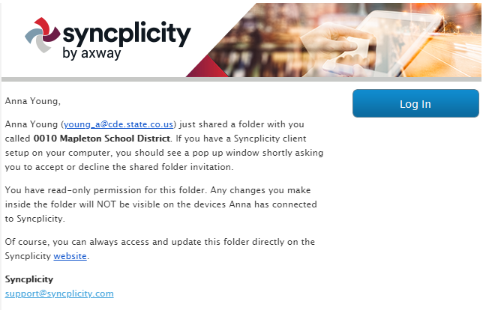
The email will instruct you to click on a link to access the Syncplicity folder. If you do not have one already, you will be asked to create an account. You will set up a free, personal edition account using the email address associated with your 21st CCLC grant.
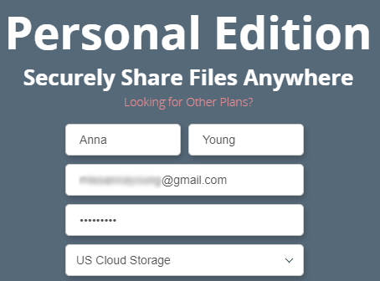

Once the account is created, you will be re-directed to the folder that your Lead Consultant has shared with you. You do not need to download the application for Syncplicity as you can access Syncplicity through your web browser. However, in the event that you need to move files between folders to assist with documentation organization, you will need to install the application to your computer as moving files between folders is not a function of the browser version of Syncplicity. In some instances, you may need to request permission from your district/organization IT department to install the application onto your computer.
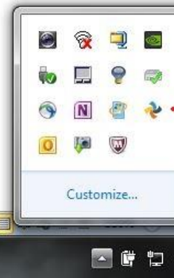
Once your account has been created, you can easily access your Syncplicity account through your web browser by typing in the URL for Syncplicity https://my.syncplicity.com/. If you download the Syncplicity application, you can also access the browser by clicking on the pinwheel icon either in your hidden icons or on your taskbar, if you save Syncplicity to your task bar, and then by clicking ‘browse’.
Once you select ‘browse’, Syncplicity will open up in your browser and you will be prompted to log in using the email address and password that were selected when creating the account.

Syncplicity Layout
Once you are signed in, you will be taken to your ‘files’ homepage within Syncplicity. At the top of the webpage, you will see options that enable you to logout, reach out for support, view your activity feed, manage shared links, install the application, and manage your account settings. The option highlighted in blue indicates the page you are currently viewing.
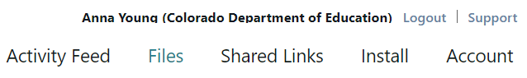
In the event you need support from Syncplicity, a new webpage will open up when you click on “Support” in the upper right hand corner of your page. You can also access the support page at https://syncplicity.zendesk.com/hc/en-us.

Activity Feed
The activity feed page includes a log of the most recent events that have taken place in your account. You can see actions that have been performed by yourself or anyone else who has access to your shared files and folders. This includes files or folders that are created and deleted. In the event you accidentally deleted a file within one of your folders, you can retrieve it by clicking on the same file within your activity feed if needed.

Files
The files page includes all files that you have created or that have been shared with you. Files that were created by you will be blue in color, whereas files that were created by someone else and shared with you will be orange. The file type will indicate whether you are able to view or edit a given file.

Shared Links
In addition to uploading documentation files to specific folders within Syncplicity, you also have the ability to share a file that you have uploaded to your account so that anyone can access it. You have the options to restrict users who can access the file as well as create a secured shared link.

Install
The install page allows you to download Syncplicity onto your computer. There are detailed instructions on installing, registering your computer, and a tutorial that will walk you through using the downloaded application of Syncplicity as opposed to your browser. You will need to download Syncplicity onto your computer if you would like to be able to move files around within folders as this is not a function of the browser version. There are options for Mac, Android, WP8, Windows 8 App, and iPhones and iPads.

Account
The account page displays information about program ownership, total use and storage, how many computers you are syncing with your browser, and your profile information including user name and password. This is where you can go to edit existing emails (e.g. if your school district changes their email platform and all employee email addresses), add additional emails, change your user name, and change your password. You can also view your login history, show synced devices, and cancel your account from this page.
Uploading Files
Within the subgrantee folder shared with you by your Lead Consultant, you will have the ability to upload required documentation which have separate subfolder(s) within your subgrantee folder. Subgrantees are required to upload all Program Documents found on the 21st CCLC Monitoring Document Checklist as well as those documents needed for the Fiscal Desk Review.
Both the Fiscal and Program folders have subfolders labeled for each corresponding indicator the Monitoring Compliance Template (MCT). You should upload all required documents into their respective folders by indicator.
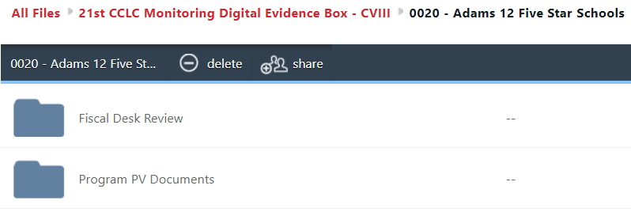
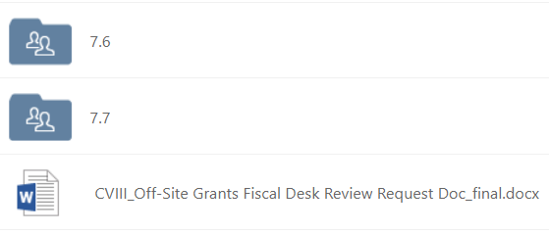
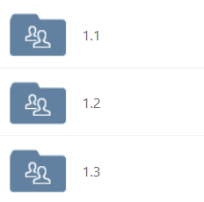

If you are using Syncplicity via a web browser, you can simply drag and drop already existing files from your computer into the folders or subfolders as needed. To upload a file into any folder, open the folder you wish to upload into and then select the “upload” button identified with the cloud and arrow.

When you click on the upload button, you will be directed to your computer files to select a file or files to upload. You can upload multiple files at one time by using your shift key to select multiples files. Clicking ‘open’ at the bottom of your window will upload the selected file. Once uploaded, you can see the date modified, what type of document, and the size of the document.
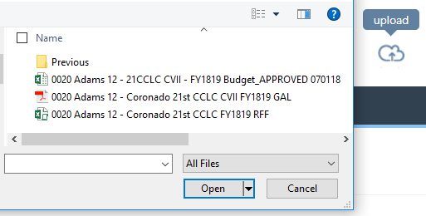
In the event you need to delete a file, right click on the file in question and then select ‘delete’. This is also where you can download a file to your own computer or identify various versions of the same file if they were manipulated or changed.

Moving Files Within Folders
In order to move files from one folder to another within Syncplicity, you must have installed the Syncplicity application to your computer. You can then select ‘manage’ instead of ‘browse’ when you click on the Syncplicity hidden icon. This brings up a summary of folders that you are the owner of or that are being shared with you. To move files within a folder, you double click on the folder in question and this will open up the downloaded version of Syncplicity on your computer. As long as the application and the browser versions are in sync (as indicated in green in the left-hand screenshot below), you should be able to access all folders in both locations and easily move files from one folder to another. The screenshot on the right captures how the files look when using the computer application.
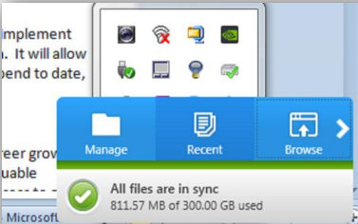
All files uploaded should be within one of the five permanent folders. In the event files are uploaded outside of these folders or in the wrong folder, you can use the Syncplicity application on your computer to move files around (copy, cut, and paste). In the screenshot below, the two files should have been uploaded into the Duplicate Count Folder. In this case, you could delete the files and re-upload them into the correct folder (the Duplicate Count folder) using the browser, or you could move the files into the correct folder using the computer application.

Moving files within folders can be useful if a subgrantee wants to duplicate files from one center subfolder to another center subfolder. Otherwise, subgrantees may keep the duplicative files to be copied into multiple folders on their computers, and can drag and drop files into the desired folder open in the web browser.

