[Insert District Name] 20__-20__ Application for Free and Reduced Price School Meals and Family Economic Data Survey
In schools participating in the Community Eligibility Program (CEP), receipt of school meals does not depend on households returning this form. In non-CEP schools, this form will be used to determine eligibility for school meals. Complete one application per household. Sections required to be completed for students in CEP and/or non-CEP schools are outlined below. Please use a black or blue pen (no pencil).

List ALL Students’ attending [Insert District Name] (if more spaces are required for additional names, attach another sheet of paper)
Foster Head
Child Start Runaway Homeless Migrant
Birth Date
M M D D Y Y
STEP 1
Grade
MI
Student’s Last Name
Student’s First Name
Check all that apply. Read How to Apply for Free and Reduced Price School Meals for more information.

If any household members (including you) currently receive assistance from any of the following programs: SNAP, TANF or FDPIR list the case number below.
STEP 2
Supplemental Nutrition Assistance Program (SNAP), Temporary Assistance for Needy Families (TANF/Colorado Works – Basic Cash Assistance or State Diversion), or Food Distribution Program on Indian Reservations (FDPIR). Provide case number and skip to Step 4.

TANF Case Number
SNAP Case Number
FDPIR Case Number
Report income for ALL household members (skip this step if you provided a case number in STEP 2)
STEP 3
How Often?
Weekly | Bi-Weekly | 2x Month | Monthly | Annually

$
$
$
$
Weekly | Bi-Weekly | 2x Month | Monthly | Annually

$
$
$
$
$
$
$
$
Earnings from Work
Student Income
$
Weekly | Bi-Weekly | 2x Month | Monthly | Annually

- Student Income
Please include the TOTAL income, if any, received by all students’ listed above.

- All Other Household Members (including yourself)
List all other household members not listed in Step 1 (including yourself) even if they do not receive income. For each household member listed, if they do receive income, report TOTAL GROSS (BEFORE TAXES AND OTHER DEDUCTIONS) for each source in whole dollars (no cents) only. If they do not receive income from any source, write ‘0’. If you enter ‘0’ or leave any fields blank, you are certifying that there is no income to report.

How Often?
How Often?
How Often?
Names of All Other Household Members
(First and Last)
Weekly | Bi-Weekly | 2x Month | Monthly | Annually

Public Assistance/
Child Support/Alimony
Pensions/Retirement/
All Other Income

Check if no SSN
XXX-XX-
Last four digits of Social Security Number (SSN) of adult signing this form or mark ‘NO SSN’
ONLY if Step 3B has been completed. This element is not required for CEP only schools.
Total Household Members
(Students’ and Adults from Steps 1 and 3)

STEP 4 Contact information and adult signature. Mail signed and completed application to: [Insert School/District Mailing Address]
“I certify (promise) that all information on this application is true and that all income is reported. I understand that the information provide may be used in connection with federal and state educational programs. Specifically, I understand the school district may get additional federal and/or state funding based on the information I have provided. By signing below I agree that my child(ren)’s eligibility status may be shared for these specific purposes and as allowed by law without specific notice and/or consent. I understand that if this information is given in connection with the receipt of Federal funds, and that school officials may verify (check) the information. I am aware that if I purposely give false information, my children may lose meal benefits, and I may be prosecuted under applicable State and Federal laws.”

Apt. # or Lot #
City
CO
Zip Code
Email Address
Phone
SIGNATURE of Adult Household Member
Printed First and Last Name of Signer
Today’s Date
Mailing Address or PO Box

STEP 5 Release of Information
The information provided on this application will be used in conjunction with state educational programs and may be shared with Medicaid or State Children’s Health Insurance Program (SCHIP) offices to seek enrollment of children into the above programs. Also, if your students are eligible to receive free or reduced price meals this information may be shared with the school/district for the purpose of waiving certain school/district program fees that your child(ren) might otherwise be required to pay. The school/district is not permitted to share your information with anyone else. You are not required to consent to the release of your information; this will not affect your student(s)’ eligibility for school meals. Your information WILL be shared unless you check one of the boxes below.

See back of application
Do NOT share my information with any programs
Do not share my information with the programs I have checked:
Medicaid/SCHIP
List Specific Program
List Specific Program

List Specific Program

List Specific Program

OPTIONAL Children’s Racial and Ethnic Identities
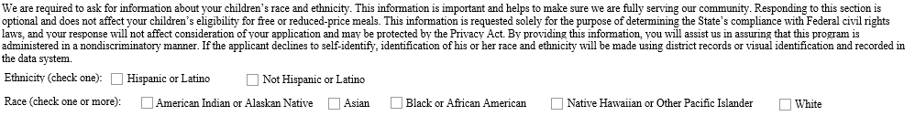

You may also qualify for the Supplemental Nutrition Assistance Program! See more information below.
Colorado PEAK is an online service for Coloradans to screen and apply for medical, food and cash assistance programs.

Visit coloradopeak.force.com to learn more.
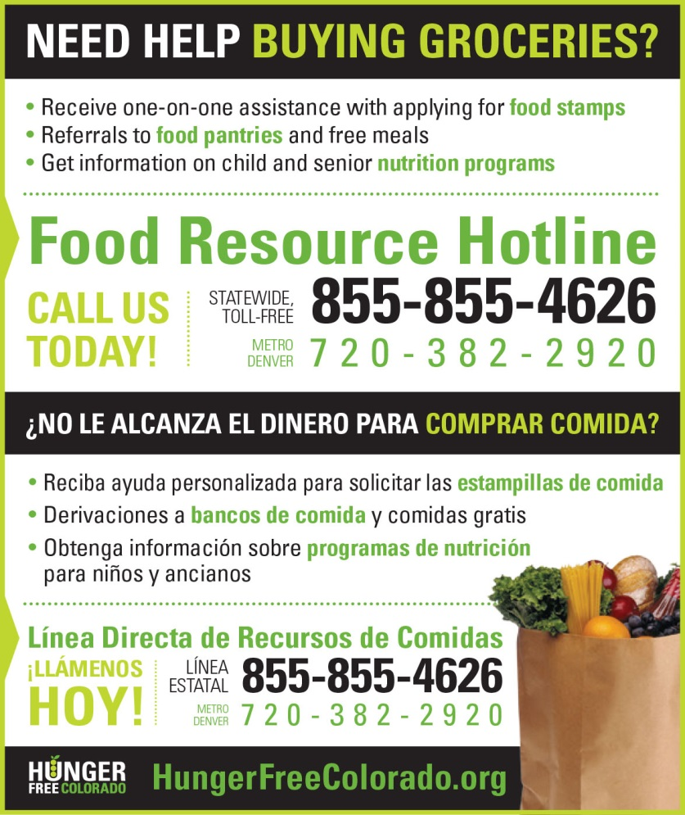
DISTRICT USE ONLY. DO NOT WRITE BELOW THIS LINE.
Annual Income Conversion: Weekly x 52; Bi-Weekly x 26; 2 Times per Month x 24; Monthly x 12
Application Type:   Total Household Income: $ Household Size:_  Household Income Frequency -  Weekly  Bi-Weekly  2x/Month Monthly Annually  Categorical Eligibility - SNAP FDPIR TANF Foster  Homeless/Migrant/Runaway/Head Start | Application Status:  Approved - Free Reduced  Denied - Over Income Guidelines Incomplete/Missing: Notes:
Determining Official Signature: Approval/Denial Date: Notification Sent:
The Richard B. Russell National School Lunch Act requires the information on this application. You do not have to give the information, but if you do not submit all needed information, we cannot approve your child for free or reduced price meals. You must include the last four digits of the social security number of the primary wage earner or other adult household member who signs the application. The social security number is not required when you apply on behalf of a foster child or you list a Supplemental Nutrition Assistance Program (SNAP), Temporary Assistance for Needy Families (TANF) Program or Food Distribution Program on Indian Reservations (FDPIR) case number or other FDPIR identifier for your child or when you indicate that the adult household member signing the application does not have a social security number. We will use your information to determine if your child is eligible for free or reduced price meals, and for administration and enforcement of the lunch and breakfast programs. We may share your eligibility information with education, health, and nutrition programs to help them evaluate, fund, or determine benefits for their programs, auditors for program reviews, and law enforcement officials to help them look into violations of program rules.

