Colorado’s District Sample Curriculum Project

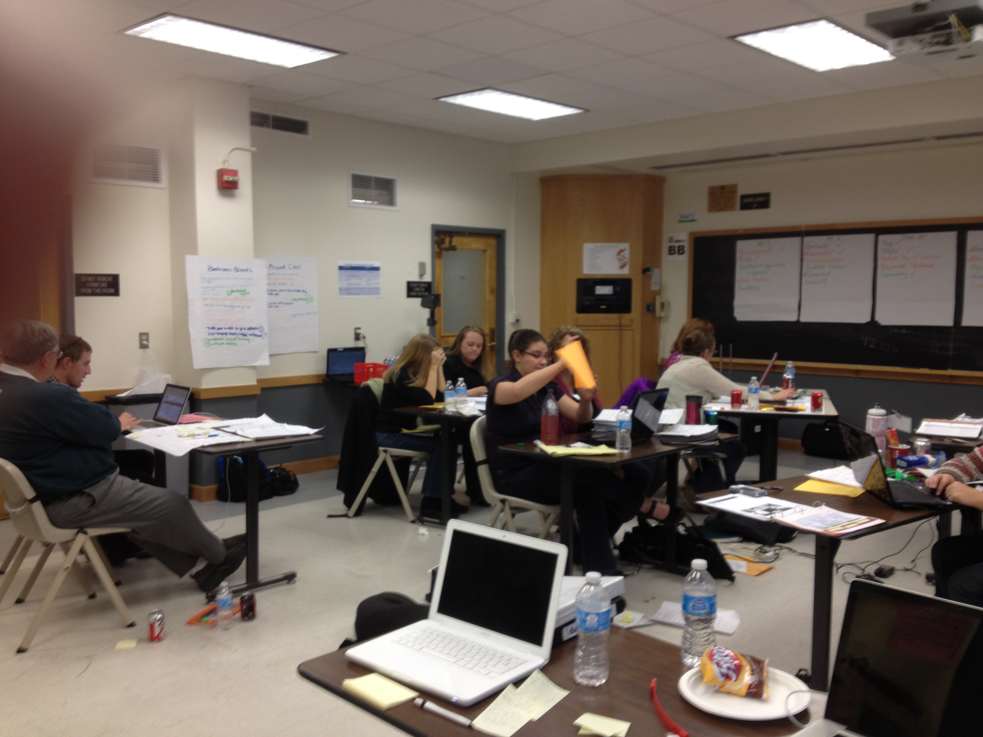

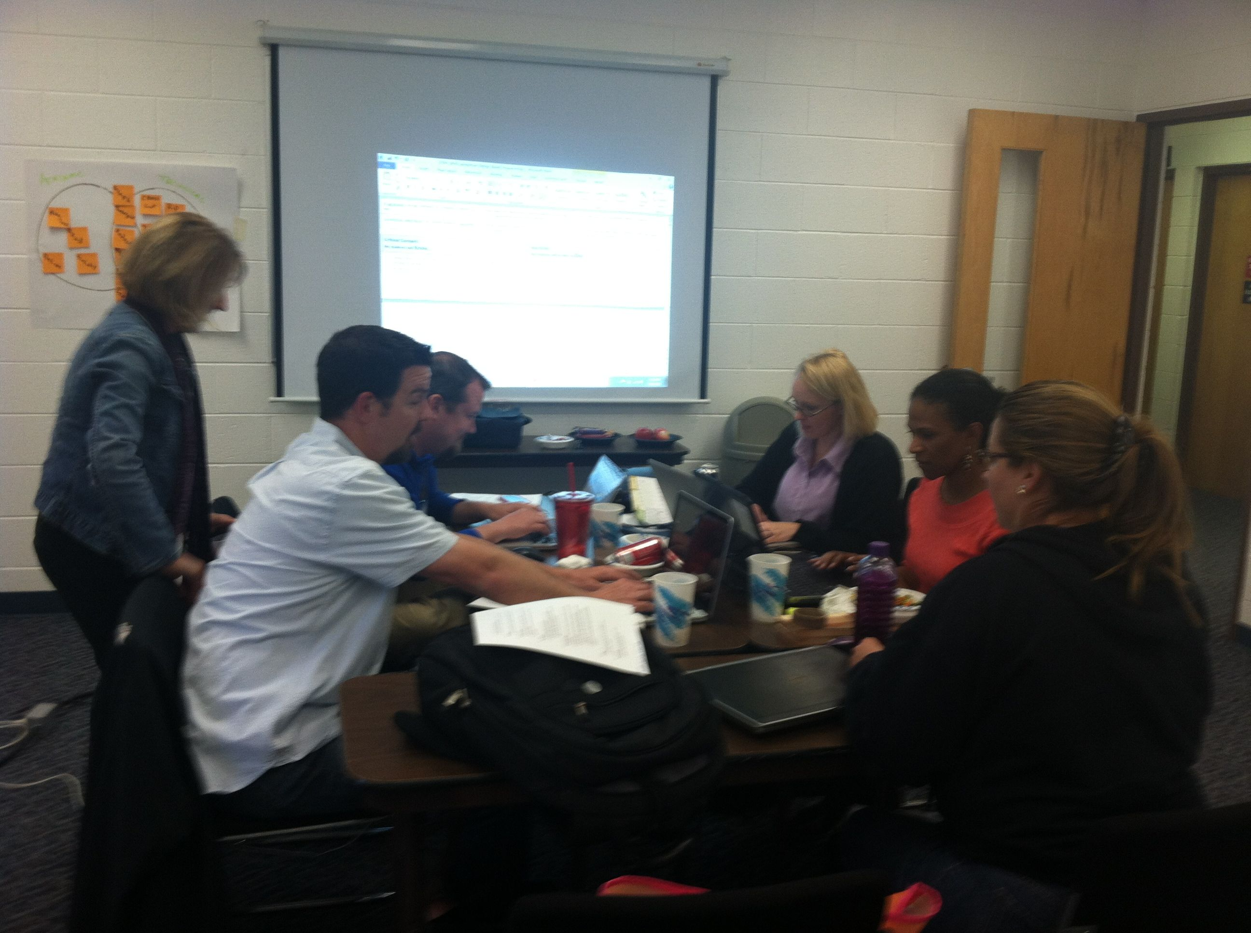

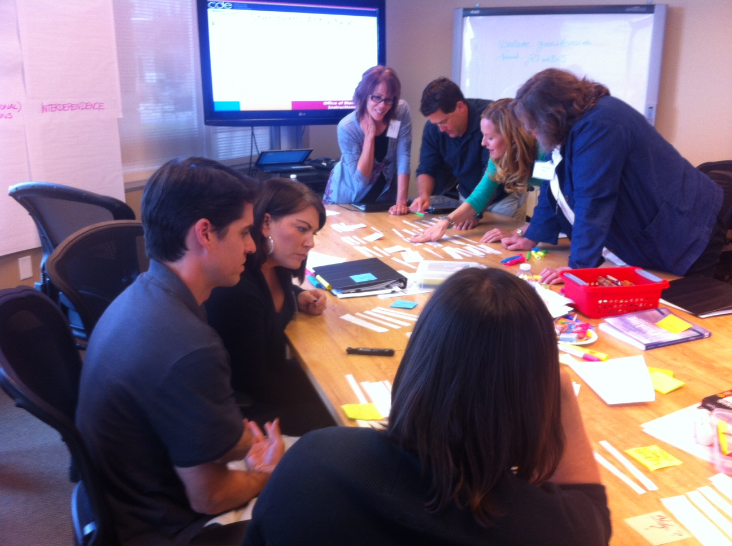

A Process Guide for Translating the Colorado Academic Standards into Curriculum Overview Samples

Acknowledgements

Thanks to Dr. Lynn Erickson for her technical assistance in helping draft the initial templates for Colorado’s District Sample Curriculum Project. Dr. Erickson and her (2007) book “Concept-Based Curriculum and Instruction for the Thinking Classroom” are constant sources of inspiration.

And a special thanks to all of the participants in the first phase of Colorado’s District Sample Curriculum Project for their dedication, hard work, creativity, and passion for ensuring that all Colorado students receive a world-class, 21st century education. Without the tireless work of these educators neither the curriculum samples nor this process guide would exist.

List of Districts with Participants in the First Phase of Colorado’s District Sample Curriculum Project

ACADEMY 20

ADAMS 12 FIVE STAR SCHOOLS

ADAMS-ARAPAHOE 28J

ALAMOSA RE-11J

ARCHULETA COUNTY 50 JT

ASPEN 1

AURORA PUBLIC SCHOOLS

BAYFIELD 10 JT-R

BENNETT 29J

BOULDER VALLEY RE 2

BYERS 32J

CENTENNIAL R-1

CENTER 26 JT

CHARTER SCHOOL INSTITUTE

CHERRY CREEK 5

CHEYENNE MOUNTAIN 12

CLEAR CREEK

COLORADO SPRINGS 11

DEL NORTE C-7

DELTA COUNTY 50(J)

DENVER COUNTY 1

DOLORES RE-4A

DOUGLAS COUNTY RE 1

EAGLE COUNTY RE 50

EAST GRAND 2

EAST OTERO R-1

EATON RE-2

ELLICOTT 22

ENGLEWOOD 1

FALCON 49

FORT MORGAN

FOUNTAIN 8

GARFIELD 16

GARFIELD RE-2

GREELEY 6

GUNNISON WATERSHED RE1J

HARRISON 2

HOLYOKE RE-1J

JEFFERSON COUNTY R-1

KEENESBURG RE-3(J)

KIM REORGANIZED 88

KIT CARSON R-1

LAKE COUNTY R-1

LITTLETON 6

MANITOU SPRINGS 14

MAPLETON 1

MESA COUNTY

MESA COUNTY VALLEY 51

MOFFAT 2

MOFFAT COUNTY RE: NO 1

MONTE VISTA C-8

MONTROSE COUNTY RE-1J

MOUNTAIN VALLEY RE 1

NORTH CONEJOS

NORTH CONEJOS RE-1J

PLATEAU RE-5

PLATEAU VALLEY 50

PLATTE VALLEY RE-7

POUDRE R-1

PRIMERO REORGANIZED 2

PUEBLO CITY 60

PUEBLO COUNTY 70

RE-1 VALLEY SCHOOLS

RIDGWAY R-2

ROARING FORK RE-1

SANGRE DE CRISTO RE-22J

SOUTH ROUTT RE 3

ST. VRAIN VALLEY RE 1J

SUMMIT RE-1

THOMPSON R-2J

VALLEY RE-1

WELD COUNTY RE-1

WIDEFIELD 3

WINDSOR RE-4

WOODLAND PARK RE-2

Colorado’s District Sample Curriculum Project:

A Process Guide for Translating the Colorado Academic Standards into Curriculum

Table of Contents

**Introduction** 2

**The Origins of Colorado’s District Sample Curriculum Project** 2

**The Goals of the Project** 2

**The Template** 3

**The Outcomes from Phase One** 3

**The Process** 4

**Starting with the Colorado Academic Standards:** 5

Identifying Concepts 5

Identifying Content 6

Identifying Skills 7

Grouping the Evidence Outcomes 8

**Creating the Unit Overview**: 12

The Unit Title 12

Standards and GLEs 13

Unit Strands 14

Focusing Lens 15

Concepts 16

Generalizations 17

Critical Content 20

Key Skills 21

Guiding Questions 22

Inquiry Questions 23

Critical Language 24

Course at a Glance 25

Appendix 26

Introduction

This guide describes a process for using the templates of Colorado’s District Sample Curriculum Project to create curriculum samples based on the Colorado Academic Standards. We begin by introducing the foundations of the Project: its origins, goals, and template. From there, details about Project outcomes segue to the processes used to create the samples. The remainder of the document is organized as a step-by-step process guide with successive sections illuminating specifics strategies for completing each section of the curriculum template.

The Origins of Colorado’s District Sample Curriculum Project

Colorado’s District Sample Curriculum Project has its roots in two nearly simultaneous events. In March, 2012, the Colorado Department of Education hosted a one-day summit on the new Colorado Academic Standards (CAS) that garnered surprisingly consistent feedback from the 450 summit-attendees regarding the “next steps” for successful standards implementation. There was, in fact, unanimity around the desire for sample curriculum based on the new standards. That same month, then president of the Colorado Association of Superintendents and Senior Administrators, Mark DeVoti, wrote a letter to Colorado school executives describing similar interest in sample curriculum. In this letter, he wrote:

“If we consider our students and schools being on a journey to reach a destination, and the Colorado Academic Standards are the road signs that guide us…wouldn’t the curriculum be the map we follow to get to our destination? And should we not all have access to the same map and the choice of whether or not to use it in reaching our common destination? If we are all travelling to the same place, why not have the option of using the same tools?”

Together, these grass-roots requests supplied the initial foundation and support for Colorado’s District Sample Curriculum Project. Since the Summit and the Devoti letter, support for sample curricula and this Project has continued to gain strength across the state.

The Standards and Instructional Support (SIS) website provides more details on the [foundations and principles](http://www.cde.state.co.us/standardsandinstruction/samplecurriculumproject-background) behind Colorado’s District Sample Curriculum Project.

The Goals of the Project

In Colorado, a local-control state, individual school districts are responsible for their own curriculum development. Successful implementation and teaching of the new Colorado Academic Standards, however, necessitates that teachers have a thorough understanding of the standards *and* a curriculum, to make the standards come alive in the classroom. Colorado’s District Sample Curriculum Project aims to strengthen capacities statewide by engaging Colorado educators in the creation of *strictly-for-voluntary-use* curriculum samples based on the standards.

As the next step in standards support for the state, Colorado’s District Sample Curriculum Project is oriented around three fundamental goals:

* **Facilitating** successful implementation of the new Colorado Academic Standards
* **Helping build** the capacity of Colorado educators to create curriculum materials based on the standards
* **Bringing together** Colorado’s educators to create a variety of samples that reflect the diversity of our school districts

Across three Project phases, thousands of Colorado educators will participate in creating unit overviews and fully-developed instructional units for all ten content areas and grades, embodying CDE’s mantra of “all student, all standards.” Educators across the state are *the* driving force behind this project, creating all the voluntary-use samples produced.

The Template

Because the Colorado Academic Standards (CAS) are concept and skill based, a significant departure from content-heavy standards, the curriculum template for creating CAS-based samples had to illuminate the connections between the content, concepts and skills of the standards. We intentionally approached the design of a template that would provide a landscape or “20,000 foot” view of curriculum; a template to illustrate the sequencing of standards across a course or a year. In the spring of 2012, Dr. Lynn Erickson, a concept-based expert, helped the Standards and Instructional Support (SIS) Team with the initial design process of this overview template.

During the summer of 2012, feedback from hundreds of Colorado educators helped shape and refine the ways in which the template provides an organized structure for addressing the standards’ grade-level expectations (GLEs), evidence outcomes (EOs) and 21st century skills that build to students' mastery of the standards at each grade level. This template:

* Centers around ideas
* Supports teaching to greater intellectual depth
* Emphasizes TRANSFER and APPLICATION of
  + - Concepts
    - Content
    - Skills

Given this feedback and the foundational belief that the template must be *flexible* enough to meet the needs of Colorado’s diverse districts, the template that resulted truly is unique to Colorado. Its design elements facilitate adaptation by individual districts/schools with varying curricular foci (e.g., Marzano, Ainsworth, and Understanding by Design).

The SIS website provides a [template with explanations](http://www.cde.state.co.us/standardsandinstruction/instructionalunitsamples) of key components/vocabulary, and a [cross-walk document](http://www.cde.state.co.us/standardsandinstruction/samplecurriculumproject-background) that highlights the connections between the template and prevalent curriculum models used in Colorado.

The Outcomes from Phase One

The Colorado Department of Education (CDE) defines curriculum as an organized plan of instruction for engaging students in mastering academic standards. Like an architectural blueprint, a curriculum provides an intentional structure to ensure all resources work together to achieve, or “build” toward, a common goal. As a blueprint delineates the interdependence of foundation and frame in relation to the goal of successful construction, a curriculum illuminates how the (structural support of) standards can connect with unit-planning to provide a pathway toward achieving meaningful learning outcomes for students.

Working with Colorado educators to create *organized plans* in the form of unit overviews, based on the CAS, was the focus of the first phase of Colorado’s District Sample Curriculum Project. In a series of curriculum design workshops conducted during the fall of 2012, Colorado educators came together to create unit overviews, based on all 10 content areas (grades k-12) of the CAS*.* Some of the highlights of these workshops include:

Participation

* + 500+ Colorado educator participants
  + 47 of 64 Colorado counties represented
  + 61 of 178 Colorado districts represented

Products

* + Nearly 700 samples (unit overviews) for all content areas (k-12) and STEM (1st, 8th, high school)
  + Samples coded to the CAS
  + Teacher/educator authorship and district affiliation on every page of the samples

These sample unit overviews provide glimpses at possible ways in which teachers could plan for sequencing the CAS across a course or a year.

The SIS website provides access to the teacher-created [samples for each content area](http://www.cde.state.co.us/StandardsAndInstruction/SampleCurriculum-samples.asp) of the standards.

The Process

The remainder of this guide, and the steps it delineates for creating the unit overviews, reflects an amalgamation of the processes used by the SIS team and Colorado educators during the phase one workshops to translate the CAS into the curriculum samples. We must begin, however, with two important caveats.

***First***, like the samples themselves this guide is not meant to be definitive or exhaustive. Instead, it reflects *one way* to use the template to:

* Provide course or year-long sequencing of concept-based unit overviews based on the Colorado Academic Standards
* Promote the instructional shifts required within the standards
* Illustrate the interdependence of grade level expectations within and across content areas within a grade.

***Second***, though this guide is linear in layout, we know that the curriculum design process is inherently iterative. Workshop participants and facilitators routinely revisited and modified their curriculum samples prior to successfully completing an aligned, standards-based, plan of instruction. Users of this guide may find it helpful to read through the guide fully before beginning any curriculum work and are encouraged to move back and forth between the sections during the actual curriculum writing process.

**\*\*\*Note: With those caveats in mind, we will use the Colorado Academic Standards for** [**4th grade social studies**](http://www.cde.state.co.us/cosocialstudies/statestandards)**, specifically the Geography standards, and one unit overview sample from 4th grade social studies,** ***Boom and Bust*****, to illuminate the specifics steps of this curriculum-writing process. This sample is also the basis for a short** [**video**](http://www.cde.state.co.us/standardsandinstruction/curriculumoverview-presentations) **that provides essential background knowledge for better understanding the template and its key features. We highly recommend watching this video prior to proceeding with the steps delineated in this guide.**

**Finally, a copy of Boom and Bust along with a Quick Guide to the terms used in the template are both available in the Appendix of this document\*\*\***

Starting with the Colorado Academic Standards- Identifying concepts

To begin the translation of CAS into curriculum, we start with the standards; in this case we are using 4th grade social studies standards. We further narrow the standards-focus in this guide and concentrate specifically on Geography Standard-2 to better clarify and illuminate the separate steps in the unit-overview process.

***Concepts are the timeless and universal aspects that provide the depth of an instructional unit- the aspects within a standard that transcend specific places, cultures, and times***.

Before we can begin forming units around the concepts, skills, and content of the CAS we must first identify these components in the standards. Owing to the concept-based nature of the CAS and the significant role of concepts in the backwards design at the heart of our template, we start with the identification of concepts. This identification requires a definition, what we mean when we say concept:

It is worth emphasizing again here that the Colorado Academic Standards are heavily concept and skill based. Mastery of the standards, defined in Colorado as students’ ability to both apply and TRANSFER their learning, is the ultimate goal. Importantly, because of their timeless and universal nature, CONCEPTS TRANSFER. Later, we will discuss the transferability of skills as well.

Starting with concepts, and this definition, curriculum writers can turn to **Standard-2 Geography** and highlight (in yellow) all of the words or phrases in the Evidence Outcomes and 21st Century Skills that represent concepts.

**\*\*\*Note: The concepts are highlighted only once as the idea is to capture, not quantify, the timeless and universal items in the standards\*\*\***

|  |  |
| --- | --- |
| **Prepared Graduates:**   * Develop spatial understanding, perspectives, and personal connections to the world | |
| **Grade Level Expectation: Fourth Grade** | |
| **Concepts and skills students master:**  1. Use several types of geographic tools to answer questions about the geography of Colorado | |
| **Evidence Outcomes** | **21st Century Skills and Readiness Competencies** |
| **Students can:**  a. Answer questions about Colorado regions using maps and other geographic tools (DOK 1-2)  b. Use geographic grids to locate places on maps and images to answer questions (DOK 1-2)  c. Create and investigate geographic questions about Colorado in relation to other places (DOK 1-3)  d. Illustrate, using geographic tools, how places in Colorado have changed and developed over time due to human activity (DOK 1-4)  e. Describe similarities and differences between the physical geography of Colorado and its neighboring states (DOK 1-2) | **Inquiry Questions:**   1. Which geographic tools are best to locate information about a place? 2. Why did settlements and large cities develop where they did in Colorado? 3. How are the regions of Colorado defined by geography? 4. How does the physical location of Colorado affect its relationship with other regions of the United States and the world? |
| **Relevance and Application:**   1. Individuals and businesses learn how to use geographic tools to answer questions about their state and region to make informed choices. For example, a family reads a weather map and researches road conditions to inform their decision to go to the mountains in the winter. 2. Individuals and businesses use geographic tools to collect and analyze data regarding the area where they live. |
| **Nature of Geography:**   1. Spatial thinkers gather appropriate tools to formulate and answer questions related to space and place. 2. Spatial thinkers use tools to compare and contrast geographic locations. |

Starting with the Colorado Academic Standards- Identifying content

Moving on, the next aspect of the standards we must identify is content. As is the case with concepts, we utilize a very particular definition of content. Here is our working definition of content:

***Content represents the “locked in time and place” topics and factual information that students must know in order to successfully master an instructional unit’s larger understandings.***

Looking for content in our standards, then, requires locating those words or phrases that DO NOT cut across time/space or have relevance beyond a particular culture or era.

Content is key to building mastery of the standards, but the content itself DOES NOT TRANSFER. Understanding the specifics of Colorado geography, for example, provides the means by which students can begin to understand larger concepts associated with the constraints and possibilities of geographic locations. But the Colorado particulars do not transfer for all locations across time.

Using this definition, curriculum writers can turn to our Standard-2 Geography and highlight (in green) all of the words or phrases in the Evidence Outcomes and 21st Century Skills that fit this definition.

**\*\*\*Note: The highlighted concepts can also represent “content” phrases when combined with descriptors that lock the concept (e.g., the concept of *regions* becomes locked in space/time content when coupled with Colorado-*Colorado regions*)\*\*\***

|  |  |
| --- | --- |
| **Prepared Graduates:**   * Develop spatial understanding, perspectives, and personal connections to the world | |
| **Grade Level Expectation: Fourth Grade** | |
| **Concepts and skills students master:**  1. Use several types of geographic tools to answer questions about the geography of Colorado | |
| **Evidence Outcomes** | **21st Century Skills and Readiness Competencies** |
| **Students can:**  a. Answer questions about Colorado regions using maps and other geographic tools (DOK 1-2)  b. Use geographic grids to locate places on maps and images to answer questions (DOK 1-2)  c. Create and investigate geographic questions about Colorado in relation to other places (DOK 1-3)  d. Illustrate, using geographic tools, how places in Colorado have changed and developed over time due to human activity (DOK 1-4)  e. Describe similarities and differences between the physical geography of Colorado and its neighboring states (DOK 1-2) | **Inquiry Questions:**   1. Which geographic tools are best to locate information about a place? 2. Why did settlements and large cities develop where they did in Colorado? 3. How are the regions of Colorado defined by geography? 4. How does the physical location of Colorado affect its relationship with other regions of the United States and the world? |
| **Relevance and Application:**   1. Individuals and businesses learn how to use geographic tools to answer questions about their state and region to make informed choices. For example, a family reads a weather map and researches road conditions to inform their decision to go to the mountains in the winter. 2. Individuals and businesses use geographic tools to collect and analyze data regarding the area where they live. |
| **Nature of Geography:**   1. Spatial thinkers gather appropriate tools to formulate and answer questions related to space and place. 2. Spatial thinkers use tools to compare and contrast geographic locations. |

Starting with the Colorado Academic Standards- Identifying skills

The final aspect we must identify in the standards is the skills. Here is our working definition of skills:

***Skills are the transferable abilities (i.e., applicable across content areas) that will be introduced and/or refined in order for students to successfully master an instructional unit’s larger understandings.***

Like concepts, skills TRANSFER across time and context. Mastering the CAS requires that students develop abilities (to think, analyze, describe, critique, etc.) that are applicable across disciplines and real world situations.

Using this definition, curriculum writers can turn to our Standard-2 Geography and highlight (in blue) all of the words or phrases in the Evidence Outcomes and 21st Century Skills that fit this definition. The concepts highlighted above can also connect with “skill” phrases when combined with verbs that define a particular attribute/ability (e.g., the concept of *regions* can be embedded within the skills associated with answering geographic questions and using geographic tools).

**\*\*\*Note: The skill statements, because of their transferable nature, cannot contain elements that lock them in particular time or to a specific place (e.g., proper nouns). Including Colorado in the skill statement “Answer questions about…,” for example, alters a transferable skill into a locked “activity” statement, applicable, in this case, only to the study of Colorado geography\*\*\***

|  |  |
| --- | --- |
| **Prepared Graduates:**   * Develop spatial understanding, perspectives, and personal connections to the world | |
| **Grade Level Expectation: Fourth Grade** | |
| **Concepts and skills students master:**  1. Use several types of geographic tools to answer questions about the geography of Colorado | |
| **Evidence Outcomes** | **21st Century Skills and Readiness Competencies** |
| **Students can:**  a. Answer questions about Colorado regions using maps and other geographic tools (DOK 1-2)  b. Use geographic grids to locate places on maps and images to answer questions (DOK 1-2)  c. Create and investigate geographic questions about Colorado in relation to other places (DOK 1-3)  d. Illustrate, using geographic tools, how places in Colorado have changed and developed over time due to human activity (DOK 1-4)  e. Describe similarities and differences between the physical geography of Colorado and its neighboring states (DOK 1-2) | **Inquiry Questions:**   1. Which geographic tools are best to locate information about a place? 2. Why did settlements and large cities develop where they did in Colorado? 3. How are the regions of Colorado defined by geography? 4. How does the physical location of Colorado affect its relationship with other regions of the United States and the world? |
| **Relevance and Application:**   1. Individuals and businesses learn how to use geographic tools to answer questions about their state and region to make informed choices. For example, a family reads a weather map and researches road conditions to inform their decision to go to the mountains in the winter. 2. Individuals and businesses use geographic tools to collect and analyze data regarding the area where they live. |
| **Nature of Geography:**   1. Spatial thinkers gather appropriate tools to formulate and answer questions related to space and place. 2. Spatial thinkers use tools to compare and contrast geographic locations. |

Starting with the Colorado Academic Standards- Grouping the Evidence Outcomes

Once we have identified the concepts, content, and skills within the standards we move on to the first step in the creation of units: grouping together Evidence Outcomes (EOs) that authentically connect. Evidence Outcomes, the indications of student mastery of the Grade Level Expectations, provide a natural basis for unit development.

Because the authors designed the CAS to connect across standard areas, the units should reflect this cross-standards intention. In order to help us see these authentic and genuine connections, we create a list of *all* the EOs for 4th grade social studies that removes the “distraction” of the standards template that might lead us to connect EOs only within standards areas (e.g., connecting all the History EOs). Once we have grouped the EOs, however, we then return to the CAS to locate the related standards and Grade Level Expectations.

Below, you will find the list of all 4th grade social studies EOs followed by a highlighted list of “grouped” EOs. This list represents the EO connections made by fall workshop participants that provided the basis for what eventually became the “Boom and Bust” unit overview. The final list (re)places the now-connected EOs back in their standards/GLE context.

**\*\*\*Note: When creating groups of connected Evidence Outcomes, curriculum writers may decide to use an EO more than once. Mastery of a given EO, for example, may not be possible in the duration or scope of one unit. Or, an EO may represent foundational knowledge requisite for understanding/accessing all the units in a specific content area for a particular grade level. Standard mastery, not standard coverage, should always guide these decisions \*\*\***

**All 4th Grade Evidence Outcomes in Social Studies**

1. Construct a timeline of events showing the relationship of events in Colorado history with events in United States and world history
2. Analyze primary source historical accounts related to Colorado history to understand cause-and-effect relationships
3. Explain the cause-and-effect relationships in the interactions among people and cultures that have lived in or migrated to Colorado
4. Identify and describe how major political and cultural groups have affected the development of the region
5. Analyze various eras in Colorado history and the relationship between these eras and eras in United States history, and the changes in Colorado over time
6. Describe interactions among people and cultures that have lived in Colorado
7. Describe the development of the political structure in Colorado history. Topics to include but not limited to an understanding of the Colorado Constitution and the relationship between state and national government
8. Describe the impact of various technological developments. Topics to include but not limited to the state of Colorado, including changes in mining technology; changes in transportation; early 20th century industrial changes; and mid- to late 20th century nuclear and computer technological changes
9. Answer questions about Colorado regions using maps and other geographic tools
10. Use geographic grids to locate places on maps and images to answer questions
11. Create and investigate geographic questions about Colorado in relation to other places
12. Illustrate, using geographic tools, how places in Colorado have changed and developed over time due to human activity
13. Describe similarities and differences between the physical geography of Colorado and its neighboring states
14. Describe how the physical environment provides opportunities for and places constraints on human activities
15. Explain how physical environments influenced and limited immigration into the state
16. Analyze how people use geographic factors in creating settlements and have adapted to and modified the local physical environment
17. Describe how places in Colorado are connected by movement of goods and services and technology
18. Define positive and negative economic incentives
19. Give examples of the kinds of goods and services produced in Colorado in different historical periods and their connection to economic incentives
20. Explain how the productive resources – natural, human, and capital – of Colorado have influenced the types of goods produced and services provided
21. Define choice and opportunity cost
22. Analyze different choices and their opportunity costs
23. Give examples of the opportunity costs for individual decisions
24. Identify risks that individuals face (PFL)
25. Analyze methods of limiting financial risk (PFL)
26. Give examples of issues faced by the state and develop possible solutions
27. Provide supportive arguments for both sides of a current public policy debate
28. Discuss how various individuals and groups influence the way an issue affecting the state is viewed and resolved
29. Explain the origins, structure, and functions of the three branches of the state government and the relationships among them
30. Identify and explain a variety of roles leaders, citizens, and others play in state government
31. Identify and explain the services state government provides and how those services are funded
32. Explain the historical foundation and the events that led to the formation of the Colorado government
33. Describe how the decisions of the state government affect local government and interact with federal law

**One Grouping of 4th Grade Evidence Outcomes (for “Boom and Bust”)**

1. Construct a timeline of events showing the relationship of events in Colorado history with events in United States and world history
2. Analyze primary source historical accounts related to Colorado history to understand cause-and-effect relationships
3. Explain the cause-and-effect relationships in the interactions among people and cultures that have lived in or migrated to Colorado
4. Identify and describe how major political and cultural groups have affected the development of the region
5. Analyze various eras in Colorado history and the relationship between these eras and eras in United States history, and the changes in Colorado over time
6. Describe interactions among people and cultures that have lived in Colorado
7. Describe the development of the political structure in Colorado history. Topics to include but not limited to an understanding of the Colorado Constitution and the relationship between state and national government
8. Describe the impact of various technological developments. Topics to include but not limited to the state of Colorado, including changes in mining technology; changes in transportation; early 20th century industrial changes; and mid- to late 20th century nuclear and computer technological changes
9. Answer questions about Colorado regions using maps and other geographic tools
10. Use geographic grids to locate places on maps and images to answer questions
11. Create and investigate geographic questions about Colorado in relation to other places
12. Illustrate, using geographic tools, how places in Colorado have changed and developed over time due to human activity
13. Describe similarities and differences between the physical geography of Colorado and its neighboring states
14. Describe how the physical environment provides opportunities for and places constraints on human activities
15. Explain how physical environments influenced and limited immigration into the state
16. Analyze how people use geographic factors in creating settlements and have adapted to and modified the local physical environment
17. Describe how places in Colorado are connected by movement of goods and services and technology
18. Define positive and negative economic incentives
19. Give examples of the kinds of goods and services produced in Colorado in different historical periods and their connection to economic incentives
20. Explain how the productive resources – natural, human, and capital – of Colorado have influenced the types of goods produced and services provided
21. Define choice and opportunity cost
22. Analyze different choices and their opportunity costs
23. Give examples of the opportunity costs for individual decisions
24. Identify risks that individuals face (PFL)
25. Analyze methods of limiting financial risk (PFL)
26. Give examples of issues faced by the state and develop possible solutions
27. Provide supportive arguments for both sides of a current public policy debate
28. Discuss how various individuals and groups influence the way an issue affecting the state is viewed and resolved
29. Explain the origins, structure, and functions of the three branches of the state government and the relationships among them
30. Identify and explain a variety of roles leaders, citizens, and others play in state government
31. Identify and explain the services state government provides and how those services are funded
32. Explain the historical foundation and the events that led to the formation of the Colorado government
33. Describe how the decisions of the state government affect local government and interact with federal law

**Grouped 4th Grade Evidence Outcomes with associated Standards and Grade Level Expectations**

**History**

1. **Organize and sequence events to understand the concepts of chronology and cause and effect in the history of Colorado**
2. Construct a timeline of events showing the relationship of events in Colorado history with events in United States and world history
3. Analyze primary source historical accounts related to Colorado history to understand cause-and-effect relationships
4. Explain the cause-and-effect relationships in the interactions among people and cultures that have lived in or migrated to Colorado
5. Identify and describe how major political and cultural groups have affected the development of the region
6. **The historical eras, individuals, groups, ideas and themes in Colorado history and their relationships to key events in the United States**
7. Analyze various eras in Colorado history and the relationship between these eras and eras in United States history, and the changes in Colorado over time
8. Describe interactions among people and cultures that have lived in Colorado
9. Describe the development of the political structure in Colorado history. Topics to include but not limited to an understanding of the Colorado Constitution and the relationship between state and national government
10. Describe the impact of various technological developments. Topics to include but not limited to the state of Colorado, including changes in mining technology; changes in transportation; early 20th century industrial changes; and mid- to late 20th century nuclear and computer technological changes

**Geography**

1. **Use several types of geographic tools to answer questions about the geography of Colorado**
2. Answer questions about Colorado regions using maps and other geographic tools
3. Use geographic grids to locate places on maps and images to answer questions
4. Create and investigate geographic questions about Colorado in relation to other places
5. Illustrate, using geographic tools, how places in Colorado have changed and developed over time due to human activity
6. Describe similarities and differences between the physical geography of Colorado and its neighboring states

**2. Connections within and across human and physical systems are developed**

1. Describe how the physical environment provides opportunities for and places constraints on human activities
2. Explain how physical environments influenced and limited immigration into the state
3. Analyze how people use geographic factors in creating settlements and have adapted to and modified the local physical environment
4. Describe how places in Colorado are connected by movement of goods and services and technology

**Economics**

1. **People respond to positive and negative incentives**
2. Define positive and negative economic incentives
3. Give examples of the kinds of goods and services produced in Colorado in different historical periods and their connection to economic incentives
4. Explain how the productive resources – natural, human, and capital – of Colorado have influenced the types of goods produced and services provided
5. **The relationship between choice and opportunity cost (PFL)**
6. Define choice and opportunity cost
7. Analyze different choices and their opportunity costs
8. Give examples of the opportunity costs for individual decisions
9. Identify risks that individuals face (PFL)
10. Analyze methods of limiting financial risk (PFL)

Creating the Unit Overview- The Unit Title

The grouping of EOs provides the necessary foundation for the creation of unit overviews and filling in the template. We begin by crafting an appropriate title that captures the connections between the EOs *and* represents an appropriate level of depth and breadth. Examples of appropriate grain size of units are illustrated below.

The initial brainstorm for units will produce more units than necessary and this list will be continually revisited throughout the curriculum writing process. In the end, we will have approximately four to six well-designed interconnected units that provide learning opportunities for the depth and breadth of the standards within the course or year.

**Continuum of Possible Units Titles**

|  |  |  |  |
| --- | --- | --- | --- |
| **Content** | **Too big** | **About right** | **Too small** |
| Math | Addition | Foundations of Addition | Fluency with Addition Facts |
| Science | Anatomy | Function of Skeletal System | Names of Bones |
| Music | Jazz | Cultural Influences of Jazz | Tempo and Structure of Jazz |
| ***Social Studies*** | ***Colorado’s economic history*** | ***Boom and Bust*** | ***Mining and Fur Trading*** |

And, once we have our title, we can begin populating the planning template; *Boom and Bust* takes its place at the top of the Unit Planning template for 4th grade Social Studies

|  |  |  |  |  |
| --- | --- | --- | --- | --- |
| **Unit Title** | Boom and Bust | | **Length of Unit** |  |
| **Focusing Lens(es)** |  | **Standards and Grade Level Expectations Addressed in this Unit** |  | |
| **Inquiry Questions (Engaging- Debatable):** |  | | | |
| **Unit Strands** |  | | | |
| **Concepts** |  | | | |

The SIS website provides copies of the [blank templates](http://www.cde.state.co.us/standardsandinstruction/curriculumoverview-templates) for each grade and content area that curriculum writers can use for creating their own CAS-based unit overviews.

Creating the Unit Overview- Standards and GLEs

|  |  |  |  |  |
| --- | --- | --- | --- | --- |
| **Unit Title** | Boom and Bust | | **Length of Unit** |  |
| **Focusing Lens(es)** |  | **Standards and Grade Level Expectations Addressed in this Unit** | SS09-GR.4-S.1-GLE.1  SS09-GR.4-S.1-GLE.2  SS09-GR.4-S.2-GLE.1  SS09-GR.4-S.2-GLE.2  SS09-GR.4-S.3-GLE.1  SS09-GR.4-S.3-GLE.2 | |
| **Inquiry Questions (Engaging- Debatable):** |  | | | |
| **Unit Strands** |  | | | |
| **Concepts** |  | | | |

Next, we populate the template with the Standards and Grade Level Expectations addressed in this particular unit. In this case, we have listed the unit’s relevant Social Studies Standards and GLEs as names *and* codes. Every content area within the Colorado Academic Standards has a coding scheme specific to each discipline and the various aspects of the standards template (GLEs, Evidence Outcomes, 21st century skills, etc).

This coding plays a key role in the curriculum samples as it provides a means to document which units address which standards/GLEs and allows curriculum writers to signify that *ALL* the GLEs and EOs are addressed in the Generalizations, Critical Content, Key Skills, and other sections of the unit overviews. Thus, as we will see, coding will show up throughout the remainder of this guide as we use Boom and Bust to illustrate this curriculum writing process.

We did, however, purposely write out the standards in the section illustrated here (something that does not occur in the samples) in order to demonstrate that users of the guide may feel free to denote standards-connections in the manner that best makes sense to them. In the remainder of this guide, however, we will use CAS coding as we document the relevant standards-based connections in the template.

A document explaining the coding of the CAS is provided in the appendix of this guide.

Creating the Unit Overview- Unit Strands

|  |  |  |  |  |
| --- | --- | --- | --- | --- |
| **Unit Title** | Boom and Bust | | Length of Unit |  |
| **Focusing Lens(es)** |  | **Standards and Grade Level Expectations Addressed in this Unit** | SS09-GR.4-S.1-GLE.1  SS09-GR.4-S.1-GLE.2  SS09-GR.4-S.2-GLE.1  SS09-GR.4-S.2-GLE.2  SS09-GR.4-S.3-GLE.1  SS09-GR.4-S.3-GLE.2 | |
| **Inquiry Questions (Engaging- Debatable):** |  | | | |
| **Unit Strands** | History, Geography, and Economics | | | |
| **Concepts** |  | | | |

Completing the Unit Strands section requires that we revisit the Evidence Outcomes with associated Standards and Grade Level Expectations list we created (See pg. 10). But first, we must define a Unit Strand:

***Unit Strands are concepts that provide a unit’s breadth-they express and represent the larger disciplinary landscape a particular unit covers.***

Unit Strands, then, are the larger concepts (***timeless and universal***) addressed in the unit*.* Fortunately, owing to the nature of our standards, the individual content areas of the CAS are typically organized in ways that authentically reflect the definition of a Unit Strand. History, geography, economics, and civics, the four standard areas, and larger concepts, for social studies are a perfect illustration.

Returning to our “Grouped” list, we can see that this unit will involve students in studying/exploring concepts, content and skills within the history, economics, and geography standards. There are no aspects of civics addressed in this particular unit, so the Unit Strands section includes three of the four larger concepts that define the social studies landscape.

Creating the Unit Overview- Focusing Lens

|  |  |  |  |  |
| --- | --- | --- | --- | --- |
| **Unit Title** | Boom and Bust | | **Length of Unit** |  |
| **Focusing Lens(es)** | (State) Cycles | **Standards and Grade Level Expectations Addressed in this Unit** | SS09-GR.4-S.1-GLE.1  SS09-GR.4-S.1-GLE.2  SS09-GR.4-S.2-GLE.1  SS09-GR.4-S.2-GLE.2  SS09-GR.4-S.3-GLE.1  SS09-GR.4-S.3-GLE.2 | |
| **Inquiry Questions (Engaging- Debatable):** |  | | | |
| **Unit Strands** | History, Geography, and Economics | | | |
| **Concepts** |  | | | |

As the Unit Strands provide the larger conceptual umbrella for the concepts within the standards, the Focusing Lens provides the overarching concept (***timeless and universal***) that frames an entire unit. Choosing a Focusing Lens is a discipline-specific decision based upon understanding the larger significance of the concepts, content, and skills to be taught in a particular unit. In other words, curriculum writers decide on the lens that *BEST* captures the significance of the unit. Indeed, significance is central to our working definition of Focusing Lens:

***The Focusing Lens is the overarching concept through which students filter information. The lens brings together concepts and content for deeper thinking and meaning making; it draws instruction (and students) continually back to the significance of what they are studying.***

Looking at our fourth grade example, the “cycles” lens focuses the unit on iterations of boom and bust in, and beyond, Colorado. The lens orients the teaching of the unit around particular connections between concepts, content, and skills in order to help students understand ***WHY*** the study of mining and the fur trade is important. The lens continually reminds us/teachers this is not a unit on mining or Colorado’s mountain men. Rather, this is a unit about the ways in which mining and Colorado mountain men illuminate the significant human dilemmas and possibilities that result from *cycles* of boom and bust.

**\*\*\*Note: The particular topics, concepts, and skills in this unit could be framed another way. We could, for example, use migration as a lens yet still include the study of mining, the fur trade, and Colorado mountain men. With a “migration” lens, however, the significance of these concepts and content might be framed in terms of the push-pull of social/economic/familial needs and why people choose or are forced to move from one location to another. In our example, however, the lens of cycles was chosen to focus this unit on developing greater understanding of the realities and consequences of boom and bust.\*\*\***

Creating the Unit Overview- Concepts

|  |  |  |  |  |
| --- | --- | --- | --- | --- |
| **Unit Title** | Boom and Bust | | **Length of Unit** | 4-5 weeks |
| **Focusing Lens(es)** | (State) Cycles | **Standards and Grade Level Expectations Addressed in this Unit** | SS09-GR.4-S.1-GLE.1  SS09-GR.4-S.1-GLE.2  SS09-GR.4-S.2-GLE.1  SS09-GR.4-S.2-GLE.2  SS09-GR.4-S.3-GLE.1  SS09-GR.4-S.3-GLE.2 | |
| **Inquiry Questions (Engaging- Debatable):** |  | | | |
| **Unit Strands** | History, Geography, and Economics | | | |
| **Concepts** | Mining, natural resources, supply and demand, opportunity cost (risks and benefits), boom and bust, regions, primary and secondary sources, cycles, culture, economy, ideas, cause and effect, space, maps, physical and geographic location, human activity, place | | | |

To populate the Concepts section of the template, we, once again, return to the “Starting with the Standards” work that began this process. Referring always to our definition of Concepts, curriculum writers can simply fill in this section with all of the highlighted-yellow terms from our standards.

***Concepts are the timeless and universal aspects that provide depth of an instructional unit- the aspects within a standard that transcend specific places, cultures, and times***.

Above we have highlighted the concepts we identified earlier (See page 5) for 4th grade Social Studies Standard-2 Geography. The remaining concepts were drawn from the history and economics standards addressed in this particular unit.

Creating the Unit Overview- Generalizations

|  |  |  |  |
| --- | --- | --- | --- |
| **Concepts** | Mining, natural resources, supply and demand, opportunity cost (risks and benefits), boom and bust, regions, primary and secondary sources, cycles, culture, economy, ideas, cause and effect, space, maps, physical and geographic location, human activity, place | | |
| **Generalizations**  **My students will Understand that…** | | **Guiding Questions**  **Factual Conceptual** | |
| Changing (or constant) values often bring about boom and bust economic cycles that shape/determine the future and direction of a state’s growth (SS09-GR.4-S.1-GLE.1-EO.b,c) | |  |  |
| Humans alter and adapt to existing natural resources to meet personal, cultural, and economic needs (SS09-GR.4-S.2-GLE.2-EO.a) | |  |  |
| Every economic decision involves both potential risks and benefits (SS09-GR.4-S.3-GLE.2-EO.a,b,c,d,e)* | |  |  |
| Physical characteristics and human activity (availability and allocation of resources) within different regions and locations contribute to the sustainability of “booms” (SS09-GR.4-S.2-GLE.1-EO.a,d) and (SS90-GR.4-S.1-GLE.2-RA.2) | |  |  |

Once concepts have been identified, curriculum team members write approximately 4 to 10 Generalizations per unit. Generalizations are the heart or backbone of the unit and represent the design-backwards point in the template; the big understandings we want students to take away from the teaching of a unit. This step is undoubtedly the most labor and time intensive. Yet the writing of Generalizations is also the most rewarding part of the process. Here is our working definition of Generalizations:

***Generalizations are the unit’s essential understandings. They connect two or more concepts in a relationship and are supported by the critical content. Generalizations represent the big/deep student understandings that build as a result of the teaching of a unit; they transfer/apply across learning experiences.***

To construct Generalizations, curriculum writers begin with the concepts (taken from the standards) populated in the Concepts section. Using the definition of Generalizations, we use content-background knowledge to determine the concepts that authentically and meaningfully connect. Next, we construct the Generalization statement that reflects the relationship between the concepts. And, we check the Generalization to ensure that it meets all the requirements of our working definition.

Using our example, we can walk through this process for one Generalization in Boom and Bust:

***Step One: Identify the concepts that are inherently and/or powerfully connected.***

The highlighted word/phrases in the Concepts section on the previous page represent concepts chosen from Standard-2 Geography and Standard 3-Economics for which the authors of this unit saw a relationship. As with choosing the Focusing Lens, determining related concepts is very much a discipline-specific decision. The Evidence Outcomes, upon which the unit is built, provide the foundation for creating these big understandings. And, a helpful tip in this process is to always remember that the concept-relationships should reflect the unit’s focus and/or title; in this case the cyclical nature of periods of boom and bust.

***Step Two: Draft/refine a Generalization statement that links the concepts in a relationship***

The Generalization highlighted in the example resulted from a process that included the crafting and editing of numerous drafts. This process starts with the crafting of an initial relationship statement, using a verb to describe the connection/relationship between the concepts. The initial draft of a Generalization may have looked like this:

**Physical locations and resources affect “booms”**

This first draft is a **“Level One” Generalization**. The statement does contain and link two concepts in a stated relationship. That relationship, however, is still rather weak; it lacks the depth that defines a Generalization. The lack of depth is clear in the verb choice; “affect” could describe any number of connections between the concepts of physical location, resources, and booms. The next step in the drafting process, then, is to attempt to strengthen the verb and the concept relationship. It may have looked like this:

**Physical characteristics and human activity contribute to “booms”**

The revised statement is now a “**Level Two” Generalization**. The statement extends the relationships by adding a concept and deepens their connection with a strong verb that lets us know the geographic concepts (physical characteristics and human activity) that actually contribute or add to economic prosperity (booms). This is now a stronger statement; it reflects the deep-understanding goals in our Generalization definition. It is a perfectly acceptable and viable Generalization. But, our final version improves on this draft. And it looks like this:

**Physical characteristics and human activity (availability and allocation of resources) within different regions and locations contribute to the sustainability of “booms”**

This final version is a **“Level Three” Generalization**. The statement contains additional concepts and establishes a stronger relationship between them. Adding “regions” and “location” strengthens the concepts at the center of the Generalization while adding the qualifying descriptor, “sustainability,” to booms more clearly defines *how* these geographic concepts contribute to economic prosperity. This Generalization links the concepts with a strong verb and tells us why the relationship between the concepts matters. This is now a very strong statement.

***Step Three: Check the Generalizations***

Curriculum creation, as noted previously, is a decidedly non-linear process. Nowhere is this more evident than in the writing of the Generalizations. Checking the Generalizations does not happen once (as a last step), but, instead recurs throughout this process. The ultimate goal is to create Generalizations that embody the ***deep and transferable*** understandings we want students to take away from the unit. Achieving this goal depends on an iterative process of crafting and refining the Generalizations.

Still, the editing/refining process must, at some point, come to a close. This list provides a means to double-check that each Generalization:

* + Contains at least two concepts
  + Links the concepts with a strong present-tense verb (see Appendix for a short list of some examples)
  + Represents a “transferable” statement (i.e., it contains no personal or proper nouns or pronouns that “lock” the Generalization to a particular time/place/culture)

**\*\*\*Note: The Generalizations are written in “teacher language.” They are not intended to reflect the vocabulary or sentence structure that students would use to express these deep understandings. Teachers seek these understandings but recognize that students will express them in developmentally appropriate ways\*\*\***

Creating the Unit Overview- Critical Content

|  |  |
| --- | --- |
| **Critical Content:**  **My students will Know…** | **Key Skills:**  **My students will be able to (Do)…** |
| * The realities and impact of the Colorado Fur Trade and the Colorado Mining Industry (SS09-GR.4-S.1-GLE.1-EO.c,d; RA.1) and (SS09-GR.4-S.3-GLE.1-EO.b) * The definition of natural resources and its specific application to the physical regions and associated populations in Colorado and neighboring states (SS09-GR.4-S.2-GLE.1-EO.a,c) * The opportunity-cost relationship that exists in any economic decision (SS09-GR.4-S.3-GLE.2-EO.a,b; N.1) * |  |

Once we have decided on the big understandings we can work backward to determine the content that is critical/essential for helping students achieve the hoped-for unit outcomes (recall our definition of content). Returning to the content highlighting from the beginning of this process (See pg. 6) we can populate this section.

***Content represents the “locked in time and place” topics and factual information that students must know in order to successfully master an instructional unit’s larger understandings.***

As we have noted throughout this guide, however, the Colorado Academic Standards are concept/skill based rather than content based. This reality presents both challenges and opportunities for curriculum writers as we cannot simply cut and paste the content from the standards into the template.

Starting with the challenges, the Critical Content section of Boom and Bust (included above) clearly illustrates the content-limitations of the CAS. This decidedly short list provides just a hint of the content needed to effectively teach this unit and help students master the standards upon which it is based.

On the other hand, the list underscores the significance of the “incomplete” nature of the curriculum samples. The insubstantial nature of Boom and Bust’s Critical Content section provides a clear and visual reminder that these truly are samples in need of fleshing out by the educators who might use them.

A second related opportunity is the manner in which this Critical Content emphasizes the importance of local/classroom based decision making. There are multiple ways to use Colorado’s history, geography and economics to teach the cyclical nature of booms and busts. Some content exists in the CAS, but curriculum writers can include content that truly reflects individual preferences and beliefs about the salient aspects of Colorado and manifestations of boom and bust cycles.

**\*\*\*Note: In some of the samples, the curriculum writers (in the fall) did add content to this section of the template. This typically happened in cases where the Colorado Academic Standards were practically content-free (e.g., 2nd grade Social Studies) Most of the time, however, the writers took the content directly from the standards. This is evident from the codes that appear at the end of the content statements\*\*\***

Creating the Unit Overview- Key Skills

|  |  |
| --- | --- |
| **Critical Content:**  **My students will Know…** | **Key Skills:**  **My students will be able to (Do)…** |
| * The realities and impact of the Colorado Fur Trade and the Colorado Mining Industry (SS09-GR.4-S.1-GLE.1-EO.c,d; RA.1) and (SS09-GR.4-S.3-GLE.1-EO.b) * The definition of natural resources and its specific application to the physical regions and associated populations in Colorado and neighboring states (SS09-GR.4-S.2-GLE.1-EO.a,c) * The opportunity-cost relationship that exists in any economic decision (SS09-GR.4-S.3-GLE.2-EO.a,b; N.1) * | * Analyze cause and effect relationships between societal values/needs and individual lives, the physical environment, and the economy (SS09-GR.4-S.1-GLE.1-EO.c) and (SS09-GR.4-S.2-GLE.1-EO.d) * Define positive/negative economic incentives (SS09-GR.4-S.3-GLE.1-EO.a) * Use maps to locate resources and regions (SS09-GR.4-S.2-GLE.1-EO.a,b,c) * Analyze primary and secondary sources to place significant events in historical sequence (SS09-GR.4-S.1-GLE.1-IQ.3) |

The Key Skill section of the template calls attention to what students should be able to do and be able to transfer to new learning experiences as a result of the unit. Recalling the skills-highlighting work we did with the standards (See pg. 7), we can complete this section.

***Skills are the transferable abilities (i.e., applicable across content areas) that will be introduced and/or refined in order for students to successfully master an instructional unit’s larger understandings.***

As with Critical Content, however, the completion of this section requires more than just cutting and pasting from the standards document. Depending on the particular unit, curriculum writers should consider combining and/or breaking down skill statements found in the Evidence Outcomes.

We can see evidence of both these approaches in the highlighted skills above. The first example combines skill statements from geography and economics standards/EOs, while the second distills the “use of geographic tools,” listed in several geography EOs, into one concise statement about map usage.

In both cases, the goal is to create skill statements that represent the essence of the attributes/abilities students will develop as they access content and master the unit’s generalizations.

**\*\*\*Note: Remember that skill statements cannot contain elements that lock them in particular time or place. “Use Colorado maps…,” instead of “Use maps to locate…” transforms that transferable skill into a locked “activity” statement, applicable, in this case, only to the study of Colorado geography\*\*\***

Creating the Unit Overview- Guiding Questions

|  |  |  |
| --- | --- | --- |
| **Generalizations**  **My students will Understand that…** | **Guiding Questions**  **Factual Conceptual** | |
| Changing (or constant) values often bring about boom and bust economic cycles that shape/determine the future and direction of a state’s growth (SS09-GR.4-S.1-GLE.1-EO.b,c) | What were the major cycles of Boom and Bust in Colorado over the past 150 years? (SS09-GR.4-S.1-GLE.2-RA.2) | How are personal or social values represented by the economic choices we make in our daily lives? |
| Humans alter and adapt to existing natural resources to meet personal, cultural, and economic needs (SS09-GR.4-S.2-GLE.2-EO.a) | Which natural resources are typically associated with the distinct physical regions of Colorado? | How do cultural beliefs, economic forces and physical resources impact land-use decisions? |
| Every economic decision involves both potential risks and benefits (SS09-GR.4-S.3-GLE.2-EO.a,b,c,d,e)* | What examples from Colorado history illustrate the social and personal components of economic risk/reward decision-making? (SS09-GR.4-S.3-GLE.2-EO.a,b) and (SS09-GR.4-S.3-GLE.2-N.1)* | Which factors are most significant in determining the right risk-benefit balance in economic decision-making? |
| Physical characteristics and human activity (availability and allocation of resources) within different regions and locations contribute to the sustainability of “booms” (SS09-GR.4-S.2-GLE.1-EO.a,d) and (SS90-GR.4-S.1-GLE.2-RA.2) | What specific resources are distinctly tied to particular regions and economic “booms” in Colorado? (SS09-GR.4-S.2-GLE.1-EO.a,c) | Who decides the best ways to manage resources to the benefit of local communities and larger state or national interests? |

The creation of Guiding Questions takes us back to the understanding we want students to develop through the teaching of this unit. Guiding questions, factual and conceptual in nature, are the inquiries that will help facilitate students’ mastery of the Generalizations. Curriculum writers will construct 3-5 factual and conceptual questions per Generalization. The Inquiry Questions within the 21st century skills sections of the CAS are extremely helpful sites for locating and/or generating guiding (conceptual) questions for the unit. Similarly, the Critical Content section provides foundational “locked in space/time” topics for creating guiding (factual) questions.

Factual and conceptual guiding questions are directly tied to the generalizations, but there are key distinctions between them.

Our working definition of factual questions: And conceptual questions:

***Factual questions are convergent questions tied to specific topics or content (locked in space/time) and typically have objective, definitive, right or wrong answers.***

***Conceptual questions are divergent questions designed to provoke thoughtful, multiple, and/or subjective answers that ask for deeper levels of thinking.***

**\*\*\*Note: As the Boom and Bust sample illustrates, the curriculum writers this fall offered examples of both types of questions within the unit overviews. They did not attempt to create all of the necessary questions\*\*\***

Creating the Unit Overview- Inquiry Questions

|  |  |  |  |  |  |
| --- | --- | --- | --- | --- | --- |
| **Unit Title** | Boom and Bust | | | **Length of Unit** | 4-5 weeks |
| **Focusing Lens(es)** | (State) Cycles | **Standards and Grade Level Expectations Addressed in this Unit** | SS09-GR.4-S.1-GLE.1  SS09-GR.4-S.1-GLE.2  SS09-GR.4-S.2-GLE.1  SS09-GR.4-S.2-GLE.2  SS09-GR.4-S.3-GLE.1  SS09-GR.4-S.3-GLE.2 | | |
| **Inquiry Questions (Engaging- Debatable):** | * ***How do the decisions we make and the values we hold affect people around us and the state in which we live? (Or, Who wore their Beaver Hat to school today)? (SS09-GR.4-S.3-GLE.1-EO.c, S.3-GLE.1-IQ.1)*** * ***Why are some demands “passing fads” while others remain constant? (SS09-GR.4-S.3-GLE.1-EO.b)*** * ***What examples of these demands are we currently experiencing? How are they connected to the unique resources of our region/state? What are their (potential) effects/impacts?*** | | | | |
| **Unit Strands** | History, Geography, and Economics | | | | |
| **Concepts** | Mining, natural resources, supply and demand, opportunity cost (risks and benefits), boom and bust, regions, primary and secondary sources, cycles, culture, economy, ideas, cause and effect, space, maps, physical and geographic location, human activity, place | | | | |

Inquiry questions are the broad, engaging questions that frame the unit. They should be relevant, catch students’ interest, and guide students’ thinking. These divergent questions cannot have “one” answer as they are intended to provide an initial spark *and* spur ongoing debate as students engage in the unit’s content and concepts.

When creating inquiry questions curriculum writers consider what will capture students’ interest and cause debate. As with the Guiding Questions, the Inquiry Questions from the Colorado Academic Standards are a good resource when creating these questions.

Importantly, the inquiry questions should directly connect to the Focusing Lens (e.g. If the conceptual lens is “influence” for a health unit, a provocative question might be, “What factors affect the choices you make about your appearance, your relationships, your future?). Looking at Boom and Bust, the Inquiry Questions around values, fads, and resources all connect with the “cycles” lens.

Creating the Unit Overview- Critical Language

|  |  |  |
| --- | --- | --- |
| **Critical Language:** includes the Academic and Technical vocabulary, semantics, and discourse which are particular to and necessary for accessing a given discipline.  EXAMPLE: A student in Language Arts can demonstrate the ability to apply and comprehend critical language through the following statement: *“Mark Twain exposes the hypocrisy of slavery through the use of satire.”* | | |
| **A student in ______________ can demonstrate the ability to apply and comprehend critical language through the following statement(s):** | | *Using diaries and other primary sources from the era of the mountain men, the cause and effect relationship of the fur trade boom is easy to see.* |
| **Academic Vocabulary:** | Cause and effect, relationships, resources | |
| **Technical Vocabulary:** | Primary and secondary sources, boom, bust, regions | |

The final section of the planning template, Critical Language, includes academic and technical vocabulary, semantics, and discourse, which are particular to and necessary for accessing a given discipline.

Critical language extends beyond vocabulary lists of terms. To attend to critical language it is imperative to determine the vocabulary, semantics and discourse, which are most critical for students to learn in each unit.

*Keep in Mind*: One of the most useful and popular ways of organizing vocabulary instruction involves using three tiers to classify words. Tier 1 includes all basic words that are well known and commonly used. Tier 2 words include a wide array of words that appear somewhat frequently and are used across content areas; academic vocabulary is included here. Tier 3 words are those that are unique to a particular context or content area (e.g. technical vocabulary).

Criteria for Identifying Possible Words to Study

* How generally useful is the word? Is it a word that students are likely to encounter in other texts? Will it be of use to students in describing their own experiences?
* Is the word required for my content area? How does the word connect to other content areas?
* Is it a word that students do not know? How deeply do they know the word?
* How does the word relate to other words, to ideas that students know or have been learning? Does it directly relate to a topic of study in the classroom? Or might it add a dimension to ideas that have been developed?
* What does the word bring to a text or situation? What role does the word play in communicating the context and/or content in which it is used? How does the meaning change in different contexts?

|  |  |  |
| --- | --- | --- |
| Organization of Words | Explanation | Examples |
| Tier 1 | Basic words, well known, often used | clock, baby, happy |
| Tier 2* | High frequency words used **across several content areas (e.g. Academic vocabulary)** | coincidence, absurd, hasty, perseverance, deconstruct, analyze, interpret, synthesize |
| Tier 3* | Low-frequency words, often **limited to specific content areas (e.g. Technical vocabulary** | nucleus, osmosis, archaeologist |

On occasion, words will have multiple and different meanings in different contexts. These words will be classified in Tier 2 (academic vocabulary) in some contexts and in Tier 3 (technical vocabulary) in others. For example: The word region has a very specific definition in geography, justifying its Tier 3 status in Boom and Bust. In another context and unit, however, region may have a very different technical or academic meaning/usage. We want to highlight and explicitly discuss similarities and differences like these while teaching vocabulary!

**\*\*\*Note: The Critical Language sections of the samples contain only examples of vocabulary relevant to each unit. No attempt was made to create extensive lists. Instead, the intent was to provide words that clarify/illustrate academic and technical vocabulary within the context of the unit\*\*\***

Creating the Unit Overview- Course at a glance

|  |  |  |  |  |  |
| --- | --- | --- | --- | --- | --- |
| **Content Area** | Social Studies | | | **Grade Level** | 4th Grade |
| **Standard** | **Grade Level Expectations (GLE)** | | | | **GLE Code** |
| 1. History | 1. Organize a sequence of events to understand the concepts of chronology and cause and effect in the history of Colorado | | | | SS09-GR.4-S.1-GLE.1 |
| 1. The historical eras, individuals, groups, ideas, and themes in Colorado history and their relationships to key events in the United States | | | | SS09-GR.4-S.1-GLE.2 |
| 1. Geography | 1. Use several types of geographic tools to answer questions about the geography of Colorado | | | | SS09-GR.4-S.2-GLE.1 |
| 1. Connections within and across human and physical systems are developed | | | | SS09-GR.4-S.2-GLE.2 |
| 1. Economics | 1. People responded to positive and negative incentives | | | | SS09-GR.4-S.3-GLE.1 |
| 1. The relationship between choice and opportunity cost (PFL) | | | | SS09-GR.4-S.3-GLE.2 |
| 1. Civics | 1. Analyze and debate multiple perspectives on an issue | | | | SS09-GR.4-S.4-GLE.1 |
| 1. The origins, structure, and functions of the Colorado government | | | | SS09-GR.4-S.4-GLE.2 |
| **Colorado 21st Century Skills**    **Critical Thinking and Reasoning:** *Thinking Deeply, Thinking Differently*  **Information Literacy:** *Untangling the Web*  **Collaboration:** *Working Together, Learning Together*  **Self-Direction:** *Own Your Learning*  **Invention:** *Creating Solutions* | |  | | | |
| **Unit Titles** | | | **Length of Unit/Contact Hours** | | **Unit Number/Sequence** |
| Boom and Bust | | | 4-5 weeks | | 4 |

Once the planning for all the units for a course or a year is complete, repeating the process we engaged in here with all the standards for 4th grade Social Studies, we can populate the course-at-a-glance. This penultimate stage of the process is the point where curriculum writers can decide both the appropriate instructional length and the sequencing of a unit.

This stage is penultimate because, as we have noted many times, the process of curriculum writing is inherently iterative in nature. Curriculum writers will want to spend some time reviewing their work, taking care to ensure the units embody all of the standards and truly reflect the goal of student mastery-the ability to both apply and transfer the desired learning in each unit.

Appendix

Quick Terms Reference Guide

* **The Focusing Lens** brings together concepts and content for deeper thinking and meaning making.
* **Inquiry Questions** engage students in the unit of study.
* **Unit Strands** are the larger concepts within a discipline (in the CAS, these are typically the standards in a discipline), and provide a *breadth* of understanding.
* **Concepts** are timeless, universal, and provide a *depth* of understanding.
* **Topics** are locked in time, place, or situation (embedded in the critical content).
* **Generalizations** are the essential and conceptual ***understandings*** in which two or more concepts are stated in a relationship and are supported by the critical content. Generalizations represent the big/deep student understandings that build as a result of the teaching of a unit; they transfer/apply across learning experiences.
* **Guiding Questions** are factual AND conceptual questions tied directly to the generalizations.
* **Critical Content** is the factual information in the unit (the topics) that students must ***know.***
* **Key Skills** are the skills students will use and develop; what they will ***do*** and be able to transfer to new learning experiences as a result of the unit.

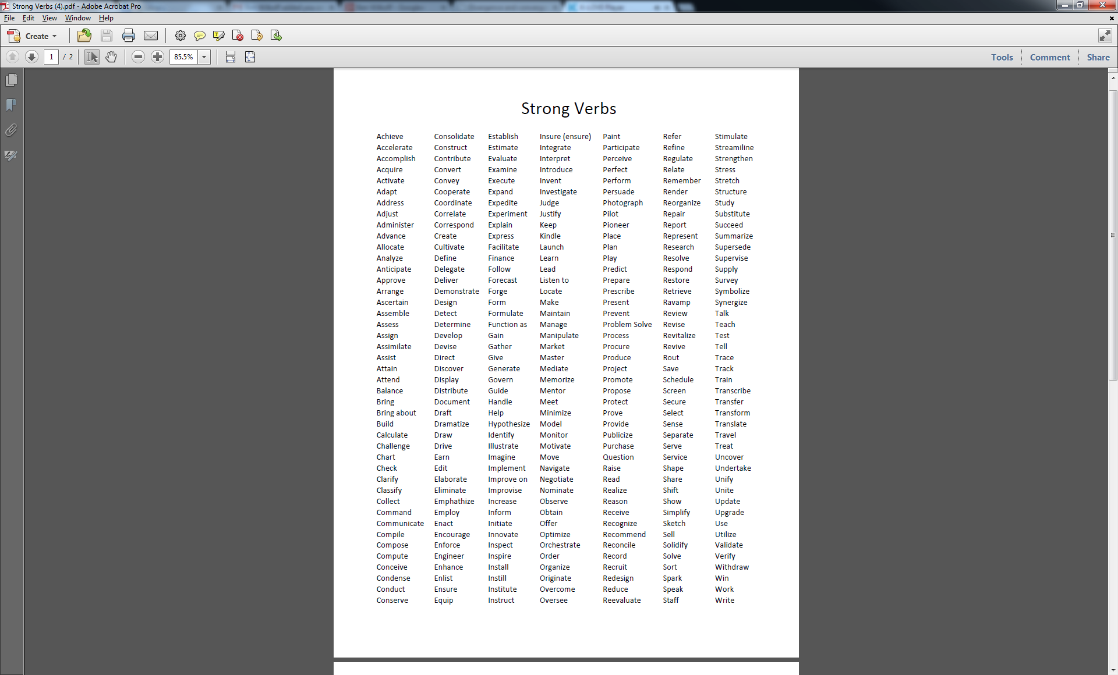

**

**NOTE:** Everything on this page of the Social Studies standards is linked to this Grade Level Expectation. Therefore, all codes will begin with this.

**NOTE:** Codes can be noted individually as demonstrated in the arrows below, or multiple elements within a single Grade Level Expectation can be combined in the following format:

(SS.09-GR.8-S.1-GLE.2-EO.b; IQ.1; RA.2; N.3)

**NOTE:** References for standards from multiple Grade Level Expectations and/or standards should be in the following format:

(SS.09-GR.8-S.1-GLE.2-EO.b; IQ.1; RA.2; N.3) and (SS.09-GR.8-S.4-GLE.1-EO.a, b; IQ.1)

|  |  |  |  |  |  |  |  |
| --- | --- | --- | --- | --- | --- | --- | --- |
| **Content Area** | Social Studies | | | **Grade Level** | 4th Grade | | |
| **Course Name/Course Code** |  | | | | | | |
| **Standard** | **Grade Level Expectations (GLE)** | | | | | | **GLE Code** |
| 1. History | 1. Organize a sequence of events to understand the concepts of chronology and cause and effect in the history of Colorado | | | | | | SS09-GR.4-S.1-GLE.1 |
| 1. The historical eras, individuals, groups, ideas, and themes in Colorado history and their relationships to key events in the United States | | | | | | SS09-GR.4-S.1-GLE.2 |
| 1. Geography | 1. Use several types of geographic tools to answer questions about the geography of Colorado | | | | | | SS09-GR.4-S.2-GLE.1 |
| 1. Connections within and across human and physical systems are developed | | | | | | SS09-GR.4-S.2-GLE.2 |
| 1. Economics | 1. People responded to positive and negative incentives | | | | | | SS09-GR.4-S.3-GLE.1 |
| 1. The relationship between choice and opportunity cost (PFL) | | | | | | SS09-GR.4-S.3-GLE.2 |
| 1. Civics | 1. Analyze and debate multiple perspectives on an issue | | | | | | SS09-GR.4-S.4-GLE.1 |
| 1. The origins, structure, and functions of the Colorado government | | | | | | SS09-GR.4-S.4-GLE.2 |
| **Colorado 21st Century Skills**    **Critical Thinking and Reasoning:** *Thinking Deeply, Thinking Differently*  **Information Literacy:** *Untangling the Web*  **Collaboration:** *Working Together, Learning Together*  **Self-Direction:** *Own Your Learning*  **Invention:** *Creating Solutions* | |  | | | | | |
| **Unit Titles** | | | **Length of Unit/Contact Hours** | | | **Unit Number/Sequence** | |
| Baby Steps: From Territory to Statehood | | | 6-8 weeks | | | 1 | |
| How We Identify Ourselves: Project ID | | | 4-6 weeks | | | 2 | |
| Choices & Consequences | | | 4-6 weeks | | | 3 | |
| Boom and Bust | | | 4-5 weeks | | | 4 | |
| Risky Business | | | 4-5 weeks | | | 5 | |

|  |  |  |  |  |  |
| --- | --- | --- | --- | --- | --- |
| **Unit Title** | Boom and Bust | | | **Length of Unit** | 4-5 weeks |
| **Focusing Lens(es)** | (State) Cycles | **Standards and Grade Level Expectations Addressed in this Unit** | SS09-GR.4-S.1-GLE.1  SS09-GR.4-S.1-GLE.2  SS09-GR.4-S.2-GLE.1  SS09-GR.4-S.2-GLE.2  SS09-GR.4-S.3-GLE.1  SS09-GR.4-S.3-GLE.2 | | |
| **Inquiry Questions (Engaging- Debatable):** | * How do the decisions we make and the values we hold affect people around us and the state in which we live? (Or, *Who wore their Beaver Hat to school today*)? (SS09-GR.4-S.3-GLE.1-EO.c, S.3-GLE.1-IQ.1) * Why are some demands “passing fads” while others remain constant? (SS09-GR.4-S.3-GLE.1-EO.b) * What examples of these demands are we currently experiencing? How are they connected to the unique resources of our region/state? What are their (potential) effects/impacts? | | | | |
| **Unit Strands** | History, Geography, and Economics | | | | |
| **Concepts** | Mining, natural resources, supply and demand, opportunity cost (risks and benefits), boom and bust, regions, primary and secondary sources, cycles, culture, economy, ideas, cause and effect, space, maps, physical and geographic location, human activity, place | | | | |

|  |  |  |
| --- | --- | --- |
| **Generalizations**  **My students will Understand that…** | **Guiding Questions**  **Factual Conceptual** | |
| Changing (or constant) values often bring about boom and bust economic cycles that shape/determine the future and direction of a state’s growth (SS09-GR.4-S.1-GLE.1-EO.b,c) | What were the major cycles of Boom and Bust in Colorado over the past 150 years? (SS09-GR.4-S.1-GLE.2-RA.2) | How are personal or social values represented by the economic choices we make in our daily lives? |
| Humans alter and adapt to existing natural resources to meet personal, cultural, and economic needs (SS09-GR.4-S.2-GLE.2-EO.a) | Which natural resources are typically associated with the distinct physical regions of Colorado? | How do cultural beliefs, economic forces and physical resources impact land-use decisions? |
| Every economic decision involves both potential risks and benefits (SS09-GR.4-S.3-GLE.2-EO.a,b,c,d,e)* | What examples from Colorado history illustrate the social and personal components of economic risk/reward decision-making? (SS09-GR.4-S.3-GLE.2-EO.a,b) and (SS09-GR.4-S.3-GLE.2-N.1)* | Which factors are most significant in determining the right risk-benefit balance in economic decision-making? |
| Physical characteristics and human activity (availability and allocation of resources) within different regions and locations contribute to the sustainability of “booms” (SS09-GR.4-S.2-GLE.1-EO.a,d) and (SS90-GR.4-S.1-GLE.2-RA.2) | What specific resources are distinctly tied to particular regions and economic “booms” in Colorado? (SS09-GR.4-S.2-GLE.1-EO.a,c) | Who decides the best ways to manage resources to the benefit of local communities and larger state or national interests? |

|  |  |
| --- | --- |
| **Critical Content:**  **My students will Know…** | **Key Skills:**  **My students will be able to (Do)…** |
| * The realities and impact of the Colorado Fur Trade and the Colorado Mining Industry (SS09-GR.4-S.1-GLE.1-EO.c,d; RA.1) and (SS09-GR.4-S.3-GLE.1-EO.b) * The definition of natural resources and its specific application to the physical regions and associated populations in Colorado and neighboring states (SS09-GR.4-S.2-GLE.1-EO.a,c) * The opportunity-cost relationship that exists in any economic decision (SS09-GR.4-.3-GLE.2-EO.a,b; N.1) * | * Analyze cause and effect relationships between societal values/needs and individual lives, the physical environment, and the economy (SS09-GR.4-S.1-GLE.1-EO.c) and (SS09-GR.4-S.2-GLE.1-EO.d) * Define positive/negative economic incentives (SS09-GR.4-S.3-GLE.1-EO.a) * Use maps to locate resources and regions (SS09-GR.4-S.2-GLE.1-EO.a,b,c) * Analyze primary and secondary sources to place significant events in historical sequence (SS09-GR.4-S.1-GLE.1-IQ.3) |

|  |  |  |
| --- | --- | --- |
| **Critical Language:** includes the Academic and Technical vocabulary, semantics, and discourse which are particular to and necessary for accessing a given discipline.  EXAMPLE: A student in Language Arts can demonstrate the ability to apply and comprehend critical language through the following statement: *“Mark Twain exposes the hypocrisy of slavery through the use of satire.”* | | |
| **A student in ______________ can demonstrate the ability to apply and comprehend critical language through the following statement(s):** | | *Using diaries and other primary sources from the era of the mountain men, the cause and effect relationship of the fur trade boom is easy to see.* |
| **Academic Vocabulary:** | Cause and effect, relationships, resources | |
| **Technical Vocabulary:** | Primary and secondary sources, boom, bust, regions | |

**\*Denotes a connection to Personal Financial Literacy (PFL)**