UIP Online System:

District Admin Guide

This document is intended for use by district-level staff coordinating improvement planning efforts or responsible for Unified Improvement Plan (UIP) submissions. This guide includes step-by-step instructions for many aspects of the UIP Online System, including accessing schools’ UIPs; “chatting” with schools, districts, and CDE using the Chatter feature; and editing and posting school and district UIPs. This guide supplements the Online System User Guide, which contains information on how to log in to the UIP Online System and complete the UIP.
Note: All screenshots are reflective of the current online system even if they contain previous years.

Table of Contents
Home Tab 1
How to Access and Download UIPs 3
UIP Tab 4
Submitting a UIP for Public Posting 5
Reports 7
Chatter 8
State Accountability Secure Data Explorer Tool 9
UIP Elements Dashboard 10
Accessing UIP Feedback 11

For additional support, please contact uiphelp@cde.state.co.us.

Home Tab
Upon logging into the UIP Online System, district users will land on the Home tab. The Home tab contains three list views (district, school, and AEC) for users to see details about all UIPs. Use the Search box in each list view to find a specific UIP.
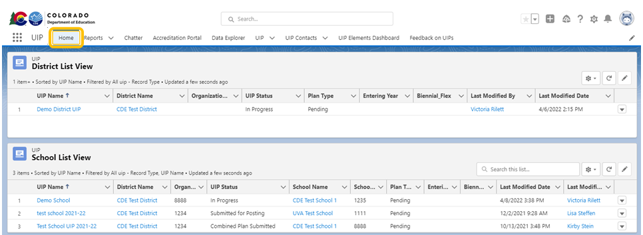

The Home tab also contains a UIP Dashboard that districts can use to monitor the status of all of their schools’ UIPs. Click the “View Report” button in each widget of the dashboard to view and download a report of the information being displayed. To export a report from the “View Report” screen, click on the arrow in the upper right corner and select “Export.”
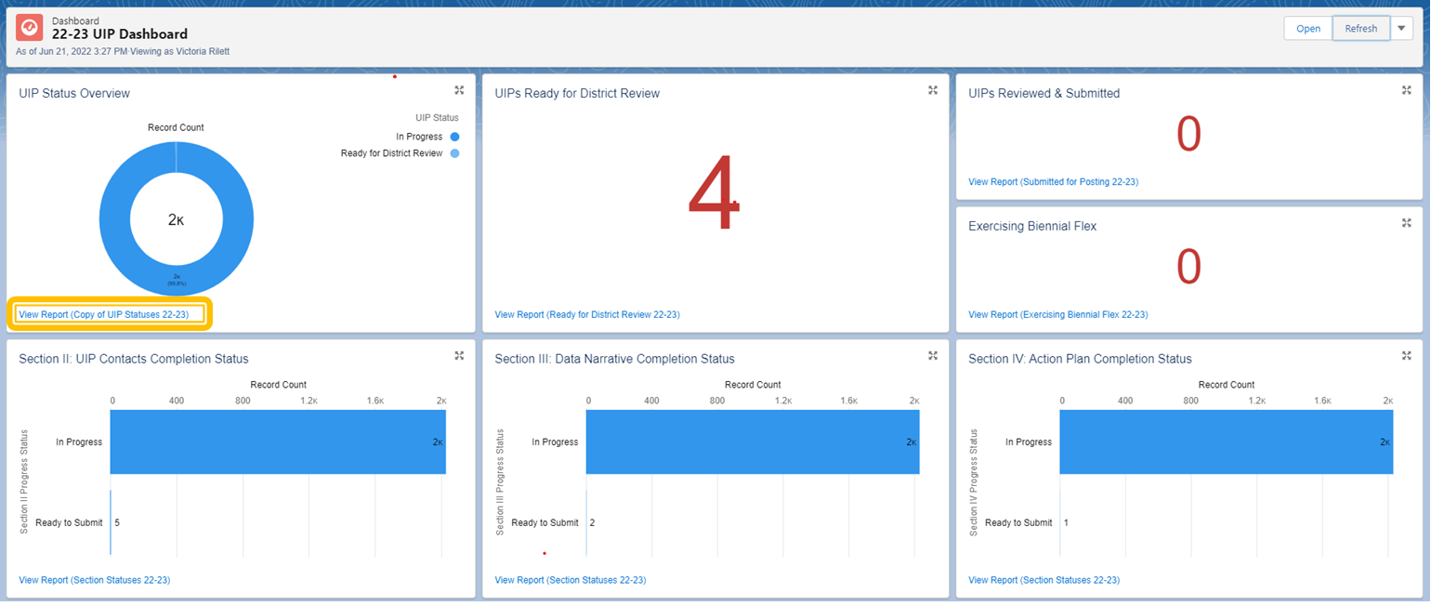

How to Access and Download UIPs
From the Home tab, users can quickly access a UIP by clicking the UIP Name in the District, School, or AEC List Views. The user will navigate to the UIP’s Details page, at which point the user must select the “UIP Home'' button on the top toolbar to view the UIP. Once in the UIP, click the “Produce Draft UIP” button to download a PDF of the UIP. Click the light blue underlined district or school name in the top left corner to return to the district administrative pages.
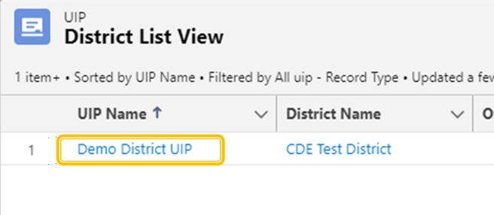

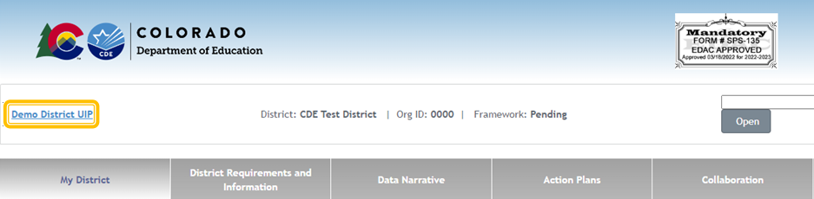
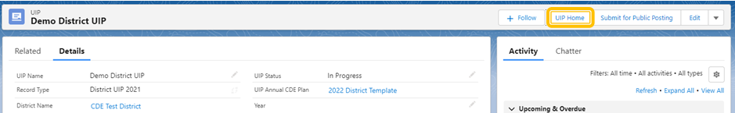

UIP Tab
The UIP Tab is another way to access both current and previous years’ UIPs. The “Recently Viewed” list shows by default. The user can use the down arrow next to the title of the list to change which list is displayed. Use the “Pin” feature to set a different list as the default for this tab. Each list view will include all UIPs in that category. To log into the UIP, click the title under the UIP Name column.
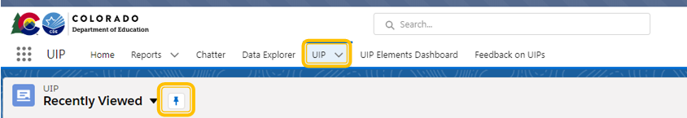
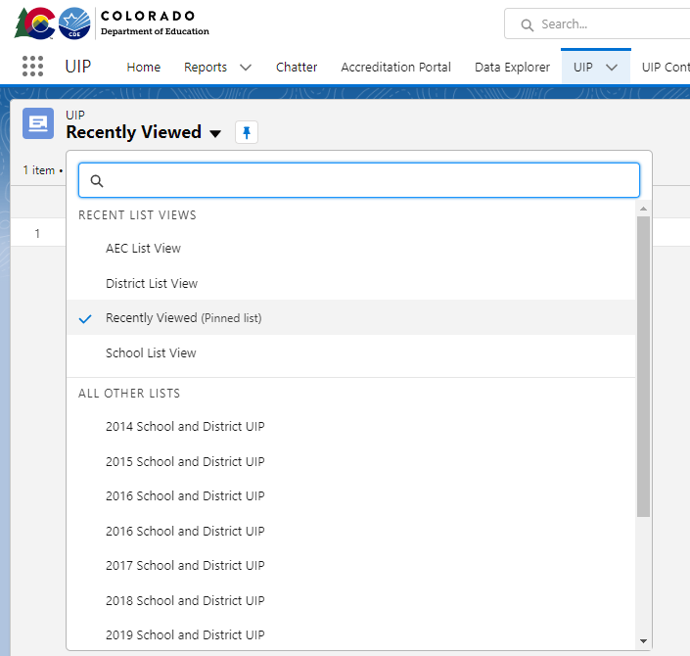

Lists for Districts
- Recently Viewed- User’s most recently viewed UIPs
- Schools Ready for District Approval- School and AEC UIPs that have been submitted for district review
- (YEAR) School and District UIP- Prior year district, school, and AEC UIPs
- *District List View- Current School Year District UIP
- *School List View- Current School Year School UIPs
- *AEC List View- Current School Year AEC UIPs
*These list views can also be found on the Home tab

Submitting a UIP for Public Posting
There are two ways for District Admins to submit UIPs for public posting on Schoolview. For information on submitting combined plans in the UIP Online System, refer to the Guidance for Combined Plans.

Option 1: Submit Plans from UIP Tab List View
Once schools (traditional or AEC) have completed the UIP and clicked “Submit for Review,” the schools will appear in the “Schools Ready for District Approval” list of the UIP tab. The district can review the UIP and then submit to the CDE website by 1. checking the box next to the school name and 2. clicking the “Submit for Public Posting” button at the top of the screen. District UIPs will appear in the “District List View” view dropdown, and can be submitted the same way.

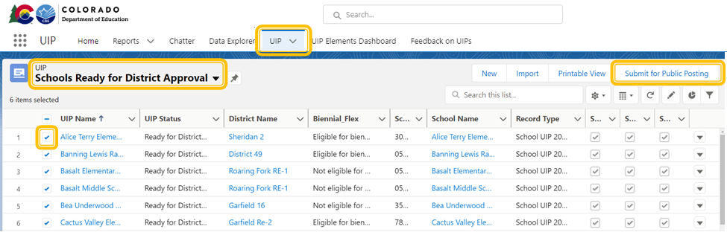

Option 2: Submit Plans from the UIP Details page
An individual school or district UIP can also be submitted for public posting on Schoolview from the UIP detail page. If the UIP has been reviewed by the district and is ready to be publicly posted, the district admin can navigate to the UIP Details page following the directions in the “Access and Download UIPs” section of this guide. Once on the UIP’s Details page, click the “Submit for Public Posting” button in the top right-hand corner of the screen. The user will be asked to confirm that you wish to submit the UIP for public posting. After clicking “Confirm,” the UIP will be submitted for public posting on Schoolview. On the UIP detail page, the UIP status will change to “Submitted for Posting.” Do not manually change the UIP Status on this page or the plan will not actually post to Schoolview.

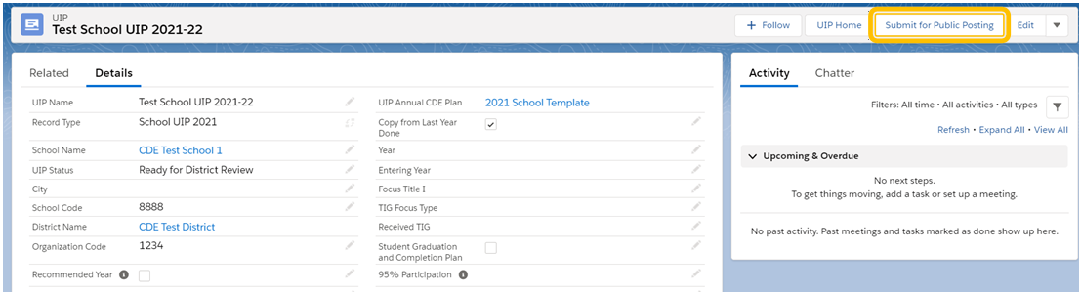
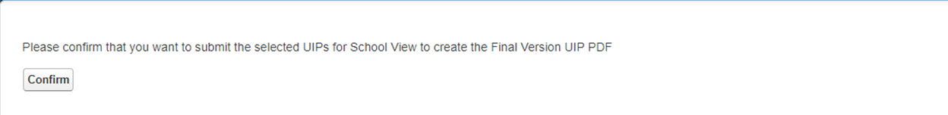

Reports
Administrative users can use the reports tab to generate excel files that include data from the district and all schools. To view already generated reports, navigate to “All Folders,” “Reports for Districts,” then select the name of the report, such as “PPC RC and MIS.” All reports will generate the specified UIP elements for this year.
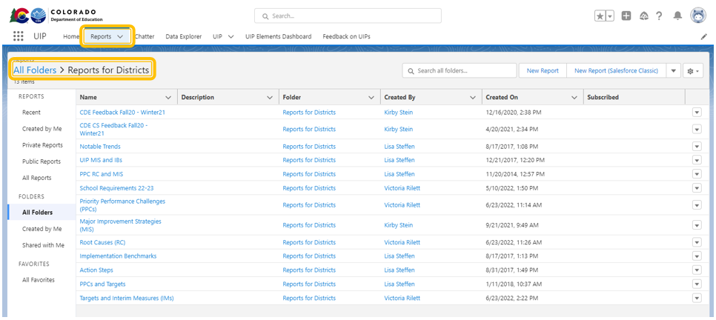

Chatter
The Chatter tab can be used to talk to CDE users, other districts, or a district’s schools (via the “Collaboration Tab” in the UIP portal).

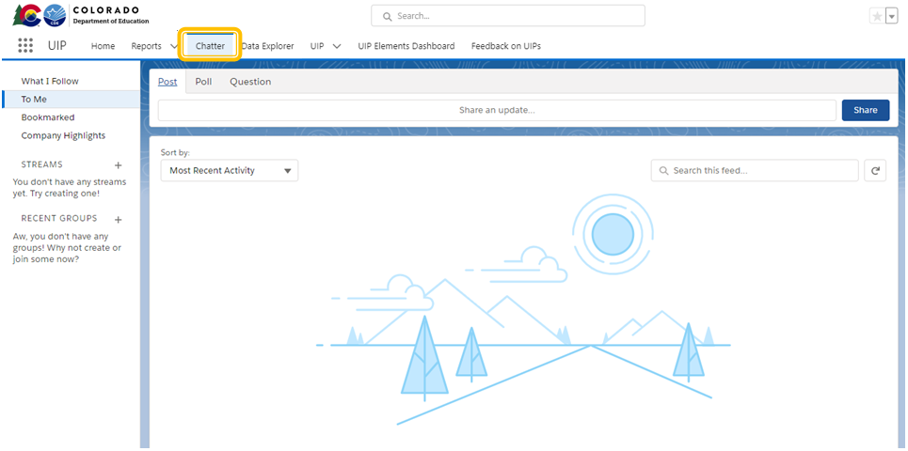

State Accountability Secure Data Explorer Tool
If the user has been assigned by the Local Access Manager (LAM) to access the Secure Data Explorer tool using the “Tableau-XXXX~ACCT_CONTACT” role, the tool will be available as a tab on the top navigation bar. As with the public version, this tool provides access to a variety of graphs and data tables showing student performance outcomes. This secure version of the tool does not apply minimum n-count conditions to the results associated with your district. However, CDE cautions against generalizing about student performance based on metrics with small n-sizes, especially those that fall below the publication threshold. The secure tool is not public, and LAMs should only authorize access to staff eligible to view student data. If the user has not been assigned by the LAM to the Accountability Contact Tableau role, this tab will prompt the user for a login and will not work.

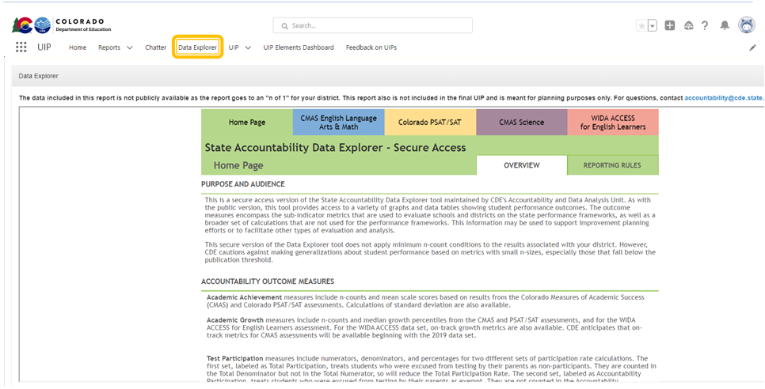

UIP Elements Dashboard
Admins can use the UIP Elements Dashboard to view all requirements for school UIPs, as well as reports of all UIP elements in the current year’s district and school UIPs. Data will only be populated in the element widgets as the district and school UIPs are completed or copied from last year. Click the “View Report” button in each widget of the dashboard to view and download a report of the information being displayed. To export a report from the “View Report” screen, click on the arrow in the upper right corner and select “Export.”

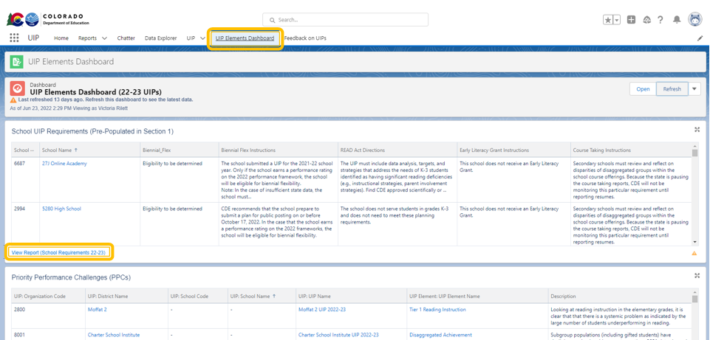

Accessing UIP Feedback
There are two ways for Admins to view UIP feedback. *Note that only plans from schools and districts that are on the clock, on watch, or identified for Comprehensive Support under ESSA receive feedback from CDE.

Option 1: Feedback Dashboard (For accessing multiple schools’ feedback at once)
The School Improvement and Planning team has created a dashboard within the UIP Online System for district level users to view UIP feedback. This feature will be most useful for districts with multiple schools receiving feedback. To access a district summary of feedback in the UIP Online system, select the “Feedback on UIPs” tab in the navigation bar. The dashboard provides summary information; “View Report” can be selected at the bottom of any component to view, export, or print more detailed feedback reports. To export a report from the “View Report” screen, click on the arrow in the upper right corner and select “Export.”
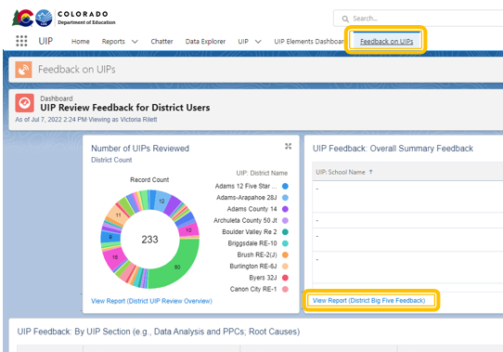
District staff responsible for ESEA programs can connect with online UIP district level administrators to access feedback for Comprehensive Support (CS) identified schools, as program feedback is consolidated in one feedback form. Feedback on CS requirements is available through the report available on the dashboard. If you need support identifying staff with those permissions in your district, please contact uiphelp@cde.state.co.us. Specifically, the report “Feedback on CS Requirements“ within the dashboard may be most useful. For additional context, the report “UIP Feedback: by UIP Section” may provide a broader understanding of overall feedback for the plan.

Option 2: Collaboration tab in the UIP (For accessing a specific schools’ feedback)
Navigate to the UIP Details page following the directions in the “Access and Download UIPs” section of this guide. Within the UIP, select the “Collaboration” tab, then select the “UIP Feedback” subtab. Users can see feedback from the past two academic years (if applicable). The feedback can be downloaded into a PDF by clicking the “Download UIP Feedback Form” button. To access previous year feedback, district users will need to go to the previous year’s plan to access the feedback through the Collaboration tab. School users do not have the ability to access previous year plans with associated feedback.

