Parent Notification and Public Hearing Requirements (2023-24)

Overview
For a school that is required to implement a Priority Improvement or Turnaround plan, there are specific expectations and timelines laid out in state accountability law about family engagement. In summary, parents must be notified about the plan type and have the opportunity to provide input into the planning process. Furthermore, schools on the accountability clock (i.e., Priority Improvement, Turnaround) must have parent involvement strategies listed in their action plans. Districts and schools in Year 3 must host a community meeting with stakeholders (e.g., local board, parents, school staff, community members) in collaboration with the department. The requirements of the hearing may be coordinated with the community meeting.

Parent Notification
The district must notify parents of the students enrolled in the school within 30 calendar days of receiving initial plan type assignment. If preliminary frameworks are released on August 23, then districts must send notification to families on or before September 22. This notification must include:
- Type of identified plan (i.e., Priority Improvement, Turnaround)
- Performance results that led to that plan assignment
- Timeline for developing and adopting the required improvement plan
- Date, time and location of the public meeting of the School Accountability Committee (SAC) to provide input on the plan
- Date, time and location of the public hearing held by the local board of education to review the plan prior to adoption.

A sample notification has been included on p. 3 of this document. If the school plan type has not yet been determined (e.g., Alternative Education Campuses, new schools), then parent notification may occur 30 calendar days after a plan type is determined. If the district applies for request to reconsider, then the notification and public hearing can wait until after the State Board’s final determination (typically in early December). If the school remains on the accountability clock, then the parent notification, SAC meeting, and local board hearing must occur prior to submission of the UIP to the state for review.

School Accountability Committee Meeting
The School Accountability Committee (SAC) is expected to meet to provide input on the improvement plan prior to the public hearing. While all SACs are expected to review a school’s UIP, provide input and conduct quarterly progress monitoring, SACs for schools on performance watch need to take special care to reflect on whether the action plan addresses the magnitude of the school’s performance challenges and whether past actions had the intended impact. Requirements, such as inclusion of family involvement strategies in the action plan and the quarterly review on the implementation of the plan, take on even greater significance. Committees should plan to review and provide feedback on improvement plans beginning in the spring in preparation for the next school year. Utilize the Accountability Committee Timeline resource for additional considerations on committee activities.

Public Hearing and Final Adoption
The date for the public hearing must be at least 30 calendar days after the date on which the district provides the written notice. This will give families ample time to get the meeting on their calendars. During these public hearings, the local board of education should review the school’s progress in implementing its plan during the preceding year and in improving its performance. A member(s) of the School Accountability Committee is encouraged to attend the public hearing. The hearing should be scheduled far enough in advance, so that any feedback provided at the hearing can be incorporated in the plan. The plan must be adopted by the local school board by October 16, which is the state’s due date for UIP submission for newly identified Priority Improvement and Turnaround plans.

Assurances
New for 2023-24, schools will be able to demonstrate compliance by marking the assurances box in the school’s Unified Improvement Plan after preliminary plan types have been released.
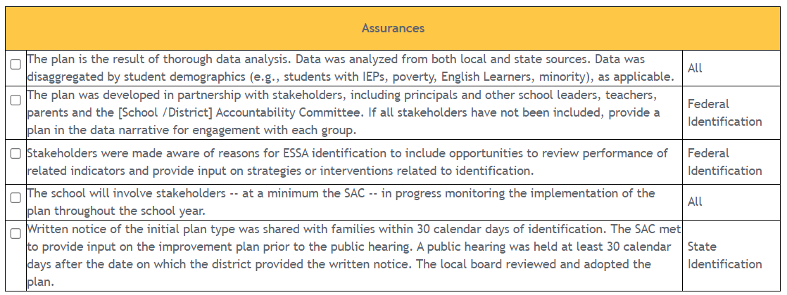

Sample Notification to Parents
To be customized based on the schools’ state identification.

[Date – By September and at least 30 days before the public hearing]]

Dear Families,

Each school in Colorado is assigned an overall school performance rating every year based on student performance and growth on state assessments. Graduation rates and college matriculation are also considered for high schools. Following the assignment of performance ratings, each school is required to develop a Unified Improvement Plan (UIP) that outlines targets for performance outcomes and strategies that the school will implement to improve academic outcomes for students.

Based on our school’s performance and growth on the 2023 state assessments given last spring, our school earned a [plan assignment] based on low-performance in the areas of [insert measures where the school did not meet expectations]. Attached is the complete 2023 School Performance Framework report that describes how our school has been evaluated.

[If applicable insert ESSA identification paragraphs here].

Our UIP will provide us with a focused improvement plan, including an analysis of student performance data and a detailed action plan. The plan must incorporate ideas and feedback from parents, be approved by the [District Name] Board of Education, and be submitted to the Colorado Department of Education on or before October 16th for review. To meet that deadline, our UIP will be developed according to the following timeline: [insert dates of any benchmarks for conducting analysis and developing and finalizing the plan].

Our School Accountability Committee will hold a public meeting to gather input from parents concerning the development of the plan on [date], at [time], in [location]. Prior to adopting a plan, our school board will hold a public hearing on [date—at least 30 days after this notice is issued], at [time], in [location] to review the plan. For more information, please contact [name] at [contact information]. [If year 3 on the clock: Because the school has progressed on the accountability clock, a community meeting will be offered to provide more information about potential next steps.]

You can learn more about Colorado’s school accountability system here: http://www.cde.state.co.us/accountability/stateaccountability. If you have any questions about our overall school performance rating or how you can get involved in our improvement efforts, please contact me.

Sincerely,

[Name}, [Title]

Template Letter for Schools Identified under ESSA
To be customized based on the schools’ identification. If the school is identified for both state and federal support and improvement, the paragraphs below can be embedded into the template for state identification (above). If the school is only identified under federal methodology, then the following can be sent as a standalone letter.

Our school has been identified for support and improvement under the federal statute, the Every Student Succeeds Act (ESSA), which means that [fill in the blank with one of the following options]

We need to improve the overall performance of all students [applicable for schools identified for Comprehensive Support and Improvement (CS-Lowest 5%)].

We need to increase the percent of students that graduate [applicable for schools identified for Comprehensive Support and Improvement (CS-Low Graduation Rate)].

We need to improve the performance of [fill in the blank from one or more of the following options as relevant] [applicable for schools identified for Target or Additional Targeted Support and Improvement (TS or ATS) based on the performance of the lists student groups]
- English learners
- Students with disabilities
- Students experiencing poverty
- Students from {fill in the race/ethnicity of the group that resulted in the school being identified}

As a result of being identified under ESSA, [name of school] is eligible for funding to help support our efforts in meeting the above goal. We will be developing an improvement plan, in partnership with stakeholders, to address the reasons that have led to [name of school] being identified.

Where can I learn more?
For additional questions, contact the School Improvement Planning team (uiphelp@cde.state.co.us)

